Guidelines for Lead Decontamination

**Introduction**

Trace amounts of lead powder being spilled is unavoidable. And like all substances if you spill it, you must be prepared to cleanup your spill. However, unlike a simple spill of a benign chemical, spills of lead compounds can expose you to levels of lead that can be harmful. Lead can cause a variety of health problems that are well documented and can even ultimately result in death. Contaminated clothing can also carry lead back to your home and possibly expose others (spouse, children) to lead as well. Therefore controlling lead levels at the source and immediately is vital in order to reduce lead exposures to you and others. The information contained in these guidelines provides laboratory users of lead the knowledge and confidence on the decontamination procedures described below. Utilizing these procedures and methods will reduce lead levels in the lab and thereby reduce your (and others) exposure to harmful lead.

**Materials Needed**

**Cleaning materials**

Materials for lead decontamination are available through the chemical warehouse.

* Hygenall Lead Off cleaner (SAP# 3000011941, 946 ml)
* Hygenall Lead Off wet wipes (SAP# 3000011942, 1000 wipes)

The above items along with some basic materials (paper towels, etc), and a little work are all that is needed to successfully decontaminate lab surfaces for lead.

**Personal Protective Equipment (PPE)**

Standard laboratory PPE (safety glasses, disposable nitrile gloves, and lab coat) should be adequate for the decontamination procedure described below. See [PPE Standard for KAUST Laboratories](https://hse.kaust.edu.sa/Services/PublishingImages/Pages/labsafety/PPE_Standard_For_KAUST_Laboratories.pdf) if you are unsure or don’t know. However, if work involved creates dust then one must first enroll in the [Respiratory Protection Program](https://hse.kaust.edu.sa/Services/Pages/respiratoryprotectiontraining.aspx) before ordering and utilizing a respirator. Contact [researchsafety@kaust.edu.sa](mailto:researchsafety@kaust.edu.sa) if you have questions regarding respirator usage.

**Procedure**

If you work with lead compounds on a regular basis, this cleaning procedure should be performed on all horizontal surfaces (excluding glove boxes) periodically (after every work session, end of the day, end of the week). Frequency of cleaning should be a decision determined by your lab manager or principle investigator. This decision should depend on the amount and frequency of lead work being done. Wear the correct PPE described above before attempting to decontaminate any surface for lead.

1. Clean up any heavy contamination with normal cleanup methods (wisk and dust pan, etc) but do so carefully in order to avoid creating dust.
2. Thoroughly spray and wet the surface with Hygenall Lead Off solution. Wet wipes can also be used avoiding this step.
3. Then wipe up the solution with a disposable paper towel.
4. If paper towel becomes wet to the point that it no longer absorbs liquid, dispose of wet paper towel and start using a new disposable paper towel.
5. Let surface dry.
6. Repeat process again if contamination is heavy.
7. Dispose of all paper in the chemically contaminated items bin.

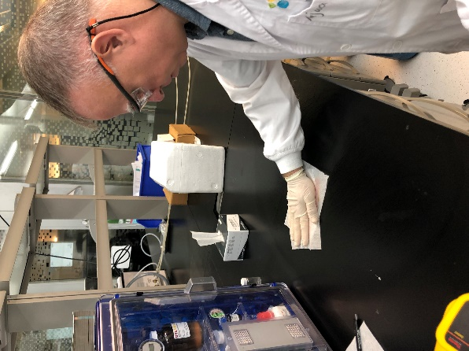

Decontaminating surfaces of lead residue can be accomplished quickly and easily with the minimum amount of materials needed. To see how effective this lead decontamination process is, see the results below.

**Experimental Decontamination Evidence**

The Research Safety Team performed lead decontamination experiments utilizing the very same materials mentioned above on known contaminated surfaces. After every cleaning, samples were taken of the surface and analyzed by ICP in the Analytical Chemistry Core Lab for lead. The results are shown below;

|  |  |  |
| --- | --- | --- |
| **Test Number** | **Cleaning order** | **ppm Pb (via ICP)** |
| **Fume Hood Experiment (Spray Solution)** | | |
| 1 | Before cleaning | 34.4 |
| 2 | After 1st cleaning | 0.7 |
| 3 | After 2nd cleaning | 0.4 |
| 4 | After 3rd cleaning | 0.3 |
| **Balance Area Experiment (Spray Solution)** | | |
| 5 | Before cleaning | 182.4 |
| 6 | After 1st cleaning | Not Detected |
| 7 | After 2nd cleaning | 0.3 |
| 8 | After 3rd cleaning | Not Detected |
| **Bench Top Surface Experiment (Wet Wipes)** | | |
| 9 | Before cleaning | 1.9 |
| 10 | After 1st cleaning | Not Detected |
| 11 | After 2nd cleaning | Not Detected |
| 12 | After 3rd cleaning | 0.56 |
| **Fume Hood Experiment (Wet Wipes)** | | |
| 13 | Before cleaning | 41 |
| 14 | After 1st cleaning | 2.7 |
| 15 | After 2nd cleaning | 0.69 |
| 16 | After 3rd cleaning | 0.69 |

As one can tell by the results, the *Hygenall Lead Off* spray solution and wet wipes are quite effective at reducing lead contamination to acceptable levels. Notice the solution is not only effective, but can dramatically drop the contamination levels in a single cleaning using the materials and procedures described here. As the results show, after one cleaning it is possible to reduce lead levels to <1ppm lead. This illustrates the importance of cleaning frequently to reduce lead contamination and exposure.

**Submitting Samples for ICP Analysis**

The Analytical Chemistry Core Lab may be able to conduct lead analyses or train users to do so independently. Contact [corelabs.services@kaust.edu.sa](mailto:corelabs.services@kaust.edu.sa) or visit the services page on the Core Labs website (<https://corelabs.kaust.edu.sa/services>) for more information. In order for a lab to submit samples to the Analytical Chemistry Core Lab, an account through Badger will be required. **Note:** Before attempting to submit samples for ICP analysis coordinate with the Analytical Chemistry Core Lab staff to determine specifics like what vials are appropriate for such analysis.

The procedure for taking lead swab checks for ICP analysis use by the Research Safety Team are as follows:

1. Freshly open a packette of 6” cotton tipped applicators/swabs, the type with wooden handles.
2. Dampen the cotton tipped part with 1 drop of distilled water or a damp paper towel.
3. Rub the cotton tipped part of the swab along the surface to be analyzed (~600 cm2 area, size of a standard A4 size sheet of paper) in a zig-zag pattern while slowly rotating the swab so as to cover all surfaces of the swab.
4. Open a fresh vial and place swab into it. Wooden handle may need to be broken off in order for it to fit in vial.
5. Label vial in a manner that makes defacing difficult.
6. Record information e.g. sample number, lab number, lab location where sample was taken, etc.

Once samples have been given to the Analytical Chemistry Core Lab and the Request For Service (RFS) has been submitted, one can expect results within a week’s time. Discuss this with the Analytical Chemistry Core Lab staff for greater detail or if you so choose to do the analysis yourself.

Contact the Research Safety Team ([researchsafety@kaust.edu.sa](mailto:researchsafety@kaust.edu.sa)) if you have questions.