Guidelines for Good Housekeeping and Labelling Containers

Maintaining good laboratory housekeeping can be challenging. Cluttered work spaces can create an environment that can lead to accidents, exposures, and injuries. Maintaining an orderly laboratory work space can easily prevent many of these laboratory incidents from happening. In addition, labelling containers, especially small vials and containers of synthetic intermediates, can also be challenging but once done correctly can not only lead to a safer work environment, but also a more efficient and organized laboratory space that can provide more consistent results. Ultimately, more organized spaces create more organized results.

**Key reasons for good housekeeping/labelling containers**

* Good housekeeping = organized lab = reliable research results
* Bad housekeeping = disorganized lab = unreliable research results
* Prevent accidents and exposures
* Positive material identification
* Helps with reagent quality

Below are a variety of simple techniques, tips, and tricks to create a more organized and safe laboratory setting.

**Chemical Fume Hoods and Biosafety Cabinets**

* Secure (*via* tie raps, cable ties, zip ties, twist ties, rubber bands, etc.) all loose and dangling electrical cords and hoses (gas, water, air) since they can pose as a snag hazard (Figure 1).

**Figure 1.** Electrical cords tied up with rubber bands and raps.

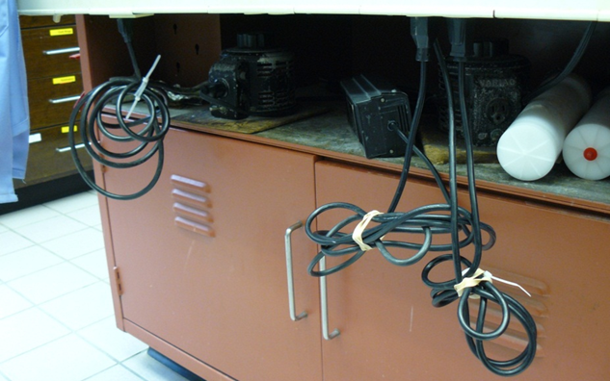

* Generally speaking, the more objects you have in your fume hood/biosafety cabinet, the less efficient it will work. Remove all unnecessary objects and clutter to make your hood/cabinet work more efficiently and to prevent accidents and exposures.
* Do not perform work or store items near the opening of a chemical fume hood/biosafety cabinet – this prevents proper air flow and increases exposure and spill hazards.
* Do not store objects near bottom baffles/vents in rear of chemical fume hoods – this prevents the chemical fume hood from working properly. To store items in back, elevate them with the use of lab jacks and a long rectangular piece of fiberglass, plastic or metal or have the workshop fashion a shelving piece – this still allows for good air flow while fulfilling storage needs (Figure 2).

**Figure 2**. Notice lab items elevated (on makeshift shelf) to allow proper chemical fume hood usage via bottom baffles.

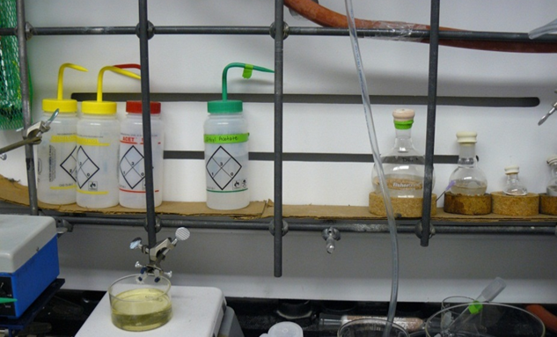

* Label all temperature baths (oil, water, sand) as this helps to identify the material if it is spilled. If material is spilled, clean it up immediately to prevent exposures and contamination.

**Figure 3.** Biosafety Cabinet good work practices.

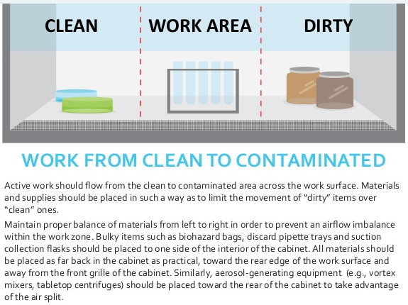

**Lab Bench**

* Organize benchtops with large equipment in the back and progressively smaller equipment toward the front. Most work takes place 6-12” from the front of the lab bench – if this space is cluttered, the rest is usually also (Figure 4).
* Keep all containers and glassware at least 2” away from the ledge of the lab bench.

**Figure 4.** Well organized and uncluttered lab bench (notice the space 6-12" from the ledge and less used items placed in back away from the ledge).

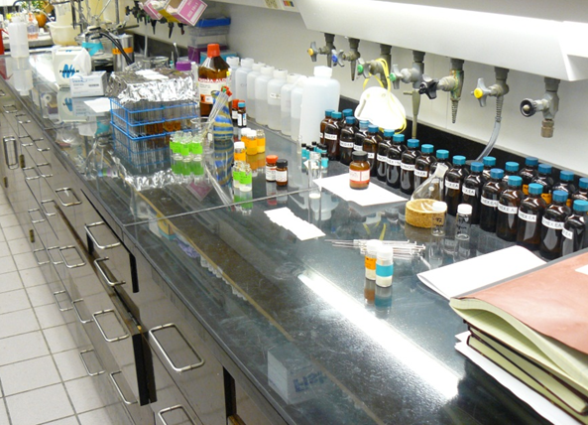

* Put into storage any clean glassware that is currently not being used and clean any dirty glassware that is taking up valuable benchtop space.
* Regularly check glassware for star cracks, chips, or cracks and promptly discard or repair any unsafe glassware before it may cause injury (Figure 5).

**Figure 5**. Discard or repair broken glassware before it can cause injury.

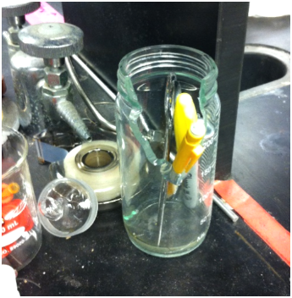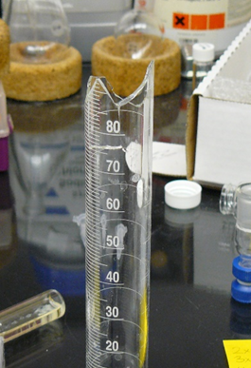

* Discard disposable pipets and TLC (thin layer chromatography) spotters immediately after use.
* Dispose of needles immediately after use in a Sharps Disposal Container or clean them (6” and 12” needles) and place them in the appropriate storage space. Unshealthed needles are an invitation for needle sticks.
* Keep drawers and cabinets closed when not in use.
* Avoid accumulating large amounts of dirty dishes in sinks and lab benches.
* Use bench paper only if you feel it is necessary and discard immediately once contaminated. Workers of biological and radiological materials tape down squares before work and then immediately remove and dispose the contaminated bench paper once work is done. This is the proper way to use bench paper. Laboratory bench tops do not need bench paper for protection and only allow spills of materials to linger about (or conceal them) which can increase your chance of a chemical exposure.

**Figures 6**. Bench paper should not be used in a semi-permanent fashion as it can increase your chance of a chemical exposure. Spilled material, whether it be toxic, corrosive, or cancer causing, may look very similar to non-hazardous material.

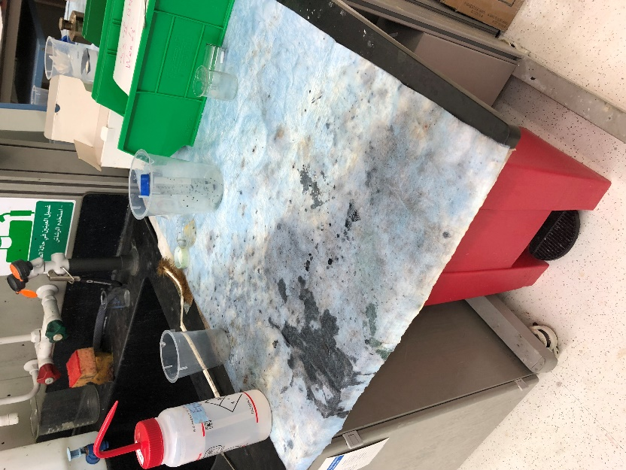 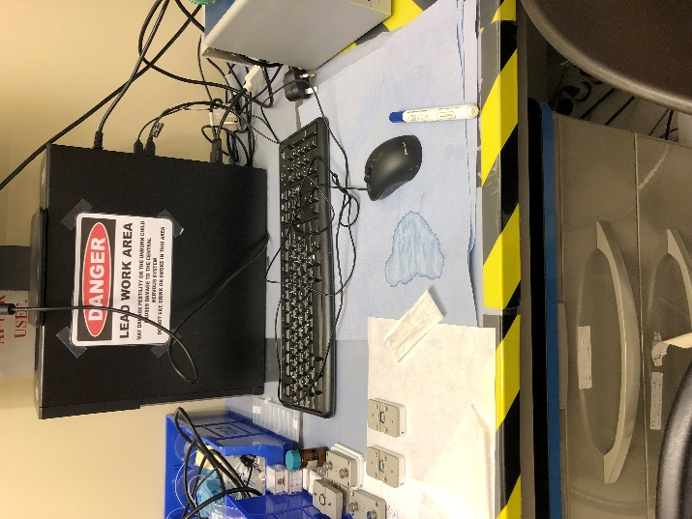

* Promptly clean up spilled chemicals, dust, silica gel and other finely powdered materials to eliminate respiratory hazards. Cleaning up spills immediately also prevents destruction of laboratory equipment as well (Figure 7).

**Figure 7**. Balance that has been damaged due to uncleaned chemical spills.

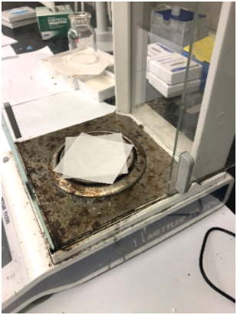

**\*A note on PPE interaction with lab clutter**

The combination of laboratory clutter and open cuffs on lab coats can make for a bad combination. If possible, use lab coats with elastic cuffs to reduce the chances of accidentally knocking over containers (vials, graduated cylinders, flasks, etc.) while reaching over these objects. Open cuffs can also get snagged on valves, clamps and other protruding equipment (Figure 8).

**Figure 8**: Loose lab coat cuffs can knock-over many items especially in a cluttrered lab space.

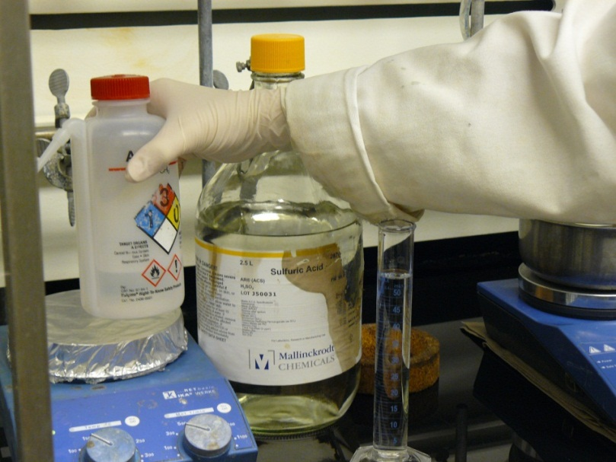

**Electrical cords**

Place electrical cords and equipment up and off the floor. This protects laboratory equipment as well as people when water spills on the floor from broken pipes.

**Vacuum pumps**

High vacuum pumps have the tendency to leak oil. A cheap and simple solution to alleviate this is to place pumps in a baking sheet with a lip as a secondary container. This allows the spilled oil to be contained and allows the vacuum pump to be moved easier by dispersing its weight over a larger surface area.

**Figures 9.** A baking sheet with a lip is an ideal secondary container to place high vacuum pumps in to contain oil spills and facilitate movement of the pump.

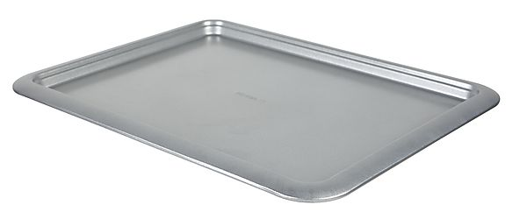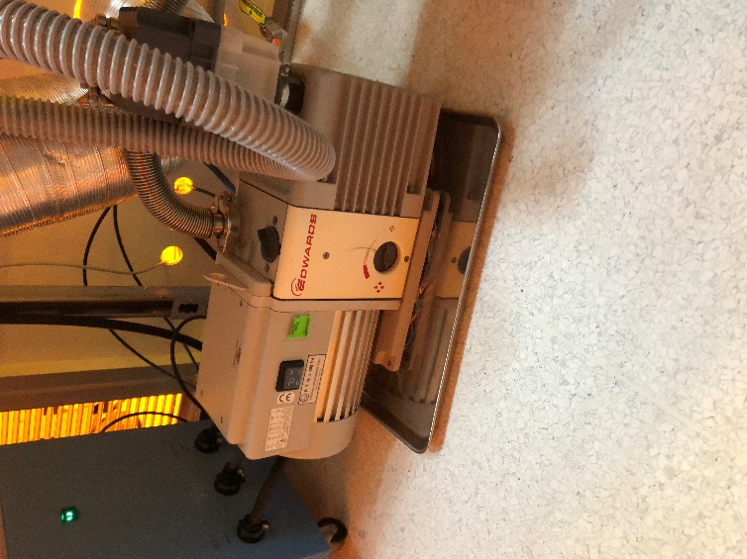

**Aisleways and Egress**

Obstructing aisles and passageways with lab equipment is not only a fire code violation but can cause slips, trips, falls and other accidents as well.

* Keep aisleways easily accessible (minimum 36” or 1 meter wide egress route), neat and free of objects that may pose an evacuation obstacle. Keep stools, waste solvent bottles and other objects near the sides of passageways.
* Be aware of where you place mobile objects (chairs, stools, carts, tables, etc.) especially those with rollers as they can easily be placed temporarily in routes of egress (Figure 10). In an emergency when quick response times are critical this can make the situation much worse.

**Figure 10.** Always keep egress routes unobstructed.

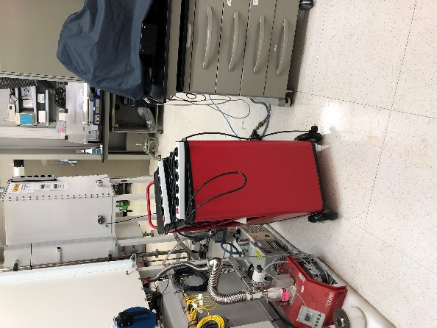

* To prevent slips, trips and falls, immediately clean up any spilled water, oil (leaking vacuum pumps) or ice on floor surfaces. Also fix any protrusions from the floor such as damaged tiles.
* Clean up any broken glassware (e.g. broken tubes), sharps or general equipment (e.g. pipette tips, TLC spotters, etc.) on floors, especially in corners. This can prevent trip hazards as well as cuts and punctures from lab personnel kneeling on floor.

**Refrigerators and Freezers**

Refrigerators and freezers pose the same problems as most other communal equipment in that everybody uses it but no single person takes care of the problems associated with it. Additionally, freezers have the maintenance problem that they need to be defrosted occasionally. The following are good tips for maintaining refrigerators/freezers in a laboratory:

* Assign shelves in refrigerator/freezers to individuals and label that shelf with the person’s name. This clearly assigns who is responsible for designated spaces.
* Perform annual defrosting of freezers to avoid ice buildup. This helps to maintain maximum freezer space and allows labs the opportunity to dispose of containers/samples that are no longer needed.
* Use secondary containers/bins to help in organizing and retrieving containers (especially the small containers) inside refrigerators/freezer shelves.

**Figure 11.** Ice buildup not only makes it difficult to retrieve items but also robs the lab of limited and valuable freezer space.

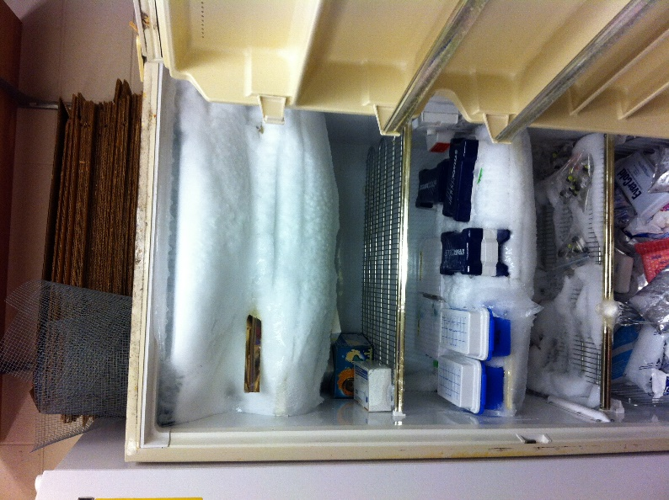

**Emergency Equipment**

Remove any equipment or clutter that interferes with access to emergency equipment such as eyewash stations, showers, fire extinguishers, fire alarms, etc. This point is critical due to the fact when emergencies happen, time is precious. Obstructions to emergency equipment can increases the severity of the emergency e.g. prolonged acid exposure to eyes, delays in fighting a fire, fire alarms unable to be activated, etc.

* Keep benchtop access around emergency eyewash stations clear.
* Keep sink basins clear of large amounts of glassware, especially protruding items that may cause harm if you suddenly have to use the sink.
* Be sure not to place objects (bins, bottles, boxes, etc) under emergency showers as this may create an obstacle to access as well as a trip hazard.

**Figure 12.** Do not block access to emergency equipment.

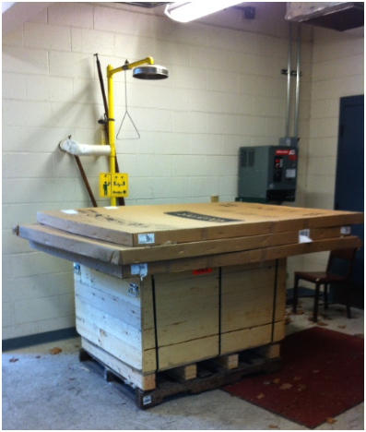

**Overhead Storage**

In order to reduce the hazards from potential fires, it is important to be mindful of overhead storage.

* There must be an 18” (0.5 meter) vertical clearance from the ceiling where sprinklers are present.
* Do not block or obstruct sprinkler heads or smoke/fire detectors as this reduces their effectiveness in detecting and extinguishing fires.
* Keep excess combustibles (e.g. cardboard boxes) to a minimum as this only adds fuel to a potential fire.

**Figure 13.** Do not block sprinkler or smoke/fire detectors by storing items close to ceiling levels.

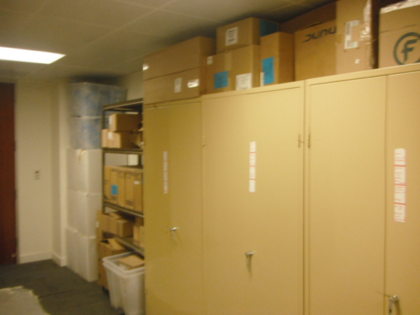

**Labelling Containers**

Many accidents and exposures have been due to unlabeled or improperly labelled containers. In addition, spill cleanups can be made more complex when the spilled material is unknown. In order to reduce the confusion of a containers contents, label containers in the following manner;

* Clear and legible! No labelling will help if the writing is not legible.
* Full name of the contents.
* In English. This is so everyone can read it.
* Do not use abbreviations/acronyms unless a key is clearly posted for everyone to read. Even then abbreviations/acronyms are highly discouraged. Example reasons;
  + DMA can mean N,N-dimethylacetamide, dimethylamine, or dimethylaniline.
  + DME can mean dimethoxyethane or dimethyl ether.
* If a liquid or solution, add percentage or concentration (e.g. neat, 6M, 10%, 5 mg/ml, 50 ppm).
* Date created, prepared or received.
* If the container is being stored/used in a common space, then a method to identify who created the container must be on the container e.g. Name or initials of person (J. Smith), notebook number, KAUST ID number, etc.
* Use markers or ink that do not dissolve in common solvents. Some label makers (e.g. ***Brother P-touch****®* label makers) create labels that are impervious to most solvents.

**Labels for small containers or synthesized compounds**

Clearly labelling the hazards of research materials that have been synthesized in the lab can be a challenge especially on a small label. In addition the name of such chemicals maybe quite lengthy, complex and impractical as the illustration below demonstrates.



(2aR,4S,4aS,6R,9S,11S,12S,12aR,12bS)-9-(((2R,3S)-3-benzamido-2-hydroxy-3-phenylpropanoyl)oxy)-12-(benzoyloxy)-4,11-dihydroxy-4a,8,13,13-tetramethyl-5-oxo-3,4,4a,5,6,9,10,11,12,12a-decahydro-1H-7,11-methanocyclodeca[3,4]benzo[1,2-b]oxete-6,12b(2aH)-diyl diacetate

In situations like this, the structure along with notebook number, page number, date, and name of researcher should be adequate. This dilemma of labelling small vials and containers that do not provide for adequate space for normal labelling methods can be overcome by the use of Avery Marking tags (Avery # 12201) as shown below in Figure 13. These tags also lend themselves to being used for labelling large flasks equally as well as the string wraps around most ground glass joint flasks.

* Properly secure and label all containers of chemicals/experimental intermediates.
* Be aware that the practice of writing information on glassware with a sharpie pen may not be as permanent as you would wish as many common solvents can easily deface and/or dissolve ink.
* Keep all containers (containing materials) closed. This not only reduces your exposure to them but also protects the material from contamination.
* Regardless of how non-hazardous the material is, **YOU MUST LABEL IT!** A spilled unlabeled container of a clear liquid can be water, sodium azide solution, aqueous sulfuric acid, aqueous sodium hydroxide, silicon oil, methanol, etc.

**Figures 14.** Avery Marking Tags (Avery #12201) are ideal for labelling/tagging small as well as large containers.

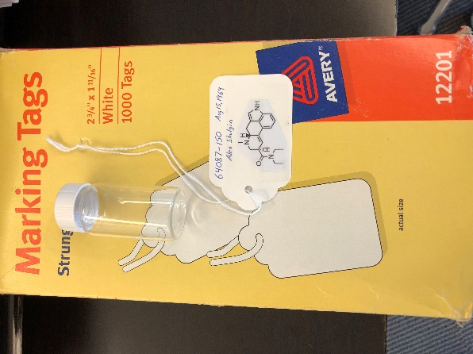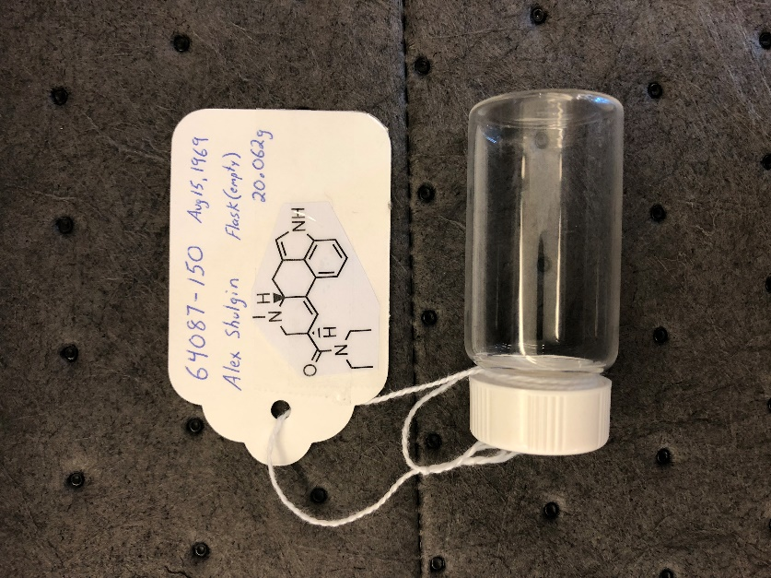

Notice tag has notebook number, date, person who created container and structure of synthesized material. Reverse side can be used to record reagent quantities, conditions, time, etc for running experiment.

**Training and Documentation**

Training conducted by (print name):____________________________________________

Trainers signature and date:__________________________________________________

Training venue and method. Check all that apply: Classroom/lab lecture

One-on-one Demonstration Hands on Experience SOP review

|  |  |  |
| --- | --- | --- |
| **Date** | **Name** | **Signature** |
|  |  |  |
|  |  |  |
|  |  |  |
|  |  |  |
|  |  |  |
|  |  |  |
|  |  |  |
|  |  |  |
|  |  |  |
|  |  |  |
|  |  |  |
|  |  |  |
|  |  |  |