Guidelines for Working with Electrical Equipment

**Introduction**

Electrically powered equipment, such as hot plates, stirrers, vacuum pumps, electrophoresis apparatus, lasers, heating mantles, ultrasonicators, power supplies, and microwave ovens are essential elements of many laboratories.  These devices can pose a significant hazard to laboratory workers, particularly when mishandled or not maintained.  Many laboratory electrical devices have high voltage or high power requirements, carrying even more risk.  Large capacitors found in many laser flash lamps and other systems are capable of storing lethal amounts of electrical energy and pose a serious danger even if the power source has been disconnected.

Safety Precautions

Laboratory workers can significantly reduce electrical hazards by following some basic precautions:

* Inspect all electrical equipment (hot plates, stirrers, ovens, extension cords, etc.) before use to ensure that cords and plugs are in good condition—not worn, twisted, frayed, abraded, corroded, or with exposed wires or missing ground pins. Live parts must be effectively insulated or physically guarded. Equipment with damaged or defective cords or plugs should be taken out of service immediately and repaired by qualified personnel.
* Use safe work practices every time electrical equipment is used.
* Know the location and how to operate shut-off switches and/or circuit breaker panels. Use these devices to shut off equipment in the event of a fire or electrocution. If circuit breaker panels are not easily accessible, consideration should be given to installing emergency shut-offs inside the lab. The photo below shows emergency shut-off button installed. This allows lab personnel to quickly shut-off electrical power in case of emergency.

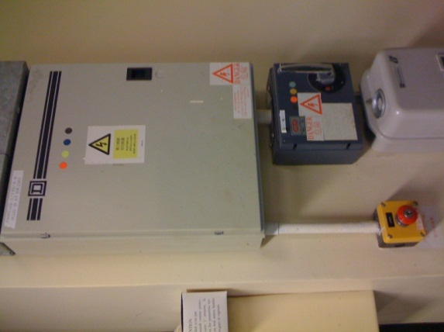

* Only equipment that is properly grounded should be used in the laboratory. See below.

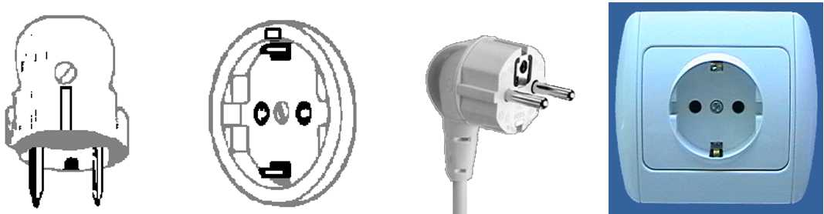

The Type F plug and outlet has two earth (ground) clips on the side.

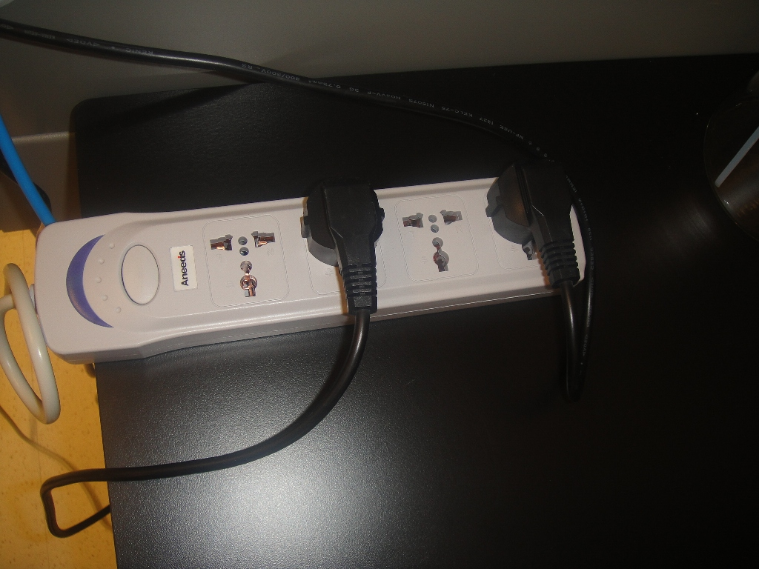

Because the Type F plug does not fit into this power strip outlet correctly, the appliance powered by the cord is NOT grounded.

* Limit the use of extension cords—they are for temporary, short-term use only. In all other cases, request the installation of a new electrical outlet. Do not use extension cords as substitution for fixed receptacle outlets. The long-term use of multi-outlet power strips is also not permitted, except for use with computer equipment.
* Ensure that all extension cords used are carefully placed, visible, and not subject to damage. Cords must not run across aisles or corridors where they might be damaged or create a tripping hazard. Cords must not run through doors, walls or partitions, under rugs, or above dropped ceilings. They must not be tied in knots, draped overhead, or attached to walls.
* Ensure that the wire size of an extension cord is adequate for the current to be carried. Failure to do so can lead to electrical fires.
* Use only multi-plug adapters equipped with circuit breakers or fuses.
* Place exposed electrical conductors (such as those sometimes used with electrophoresis devices) behind Plexiglas shields.
* Keep flammable materials away from electrical equipment.
* Keep electrical equipment away from wet or damp locations or potential water spillage, unless specifically rated for use under such conditions.
* Never obstruct electrical panels and disconnect switches. These should be clearly labeled to indicate what equipment or power source they control. A minimum of one-meter clearance must be maintained around electrical panels at all times to permit ready and safe operation and maintenance of such equipment.
* Do not overload circuits or wiring. Overloading can lead to overheated wires and arcing, which can cause fires and electrical shock injuries.
* In the event of an electrical fire, leave the area, call 911, and pull the nearest fire alarm. Do not use water on an electrical fire.

**Circuit Protection**

* No more than two high current draw devices such as ovens and centrifuges should be plugged into the same outlet to prevent an overloaded circuit. Overloading can lead to overheated wires and arcing. This can cause electrical shock injury and fire.
* Fuses and circuit breakers prevent over-heating of wires and other electrical components. This overload protection is useful for equipment that may be left on for a long time such as stirrers, drying ovens, vacuum pumps, Variacs, etc.
* Ground-fault circuit interrupters, or GFCIs, disconnect current if a ground-fault is detected and protect the user from electric shock. GFCI outlets or portable GFCIs are used near sinks and potentially wet locations. Keep electrical equipment (and yourself while you are using electrical equipment) away from water/chemical or their spills unless you are sure the equipment is rated for this type of use.

**Servicing Electrical Equipment**

* Electrical outlets, wiring, and other electrical equipment integral to the building may only be serviced and repaired by qualified building maintenance personnel or other qualified electricians.
* Work on electrical equipment must be done only after the power has been disconnected. On cord and plug connected equipment, the power cord must be unplugged and under the exclusive control of the person performing the work so that the equipment cannot be accidentally turned on by someone else. On hard-wired equipment, the main disconnect device or circuit breaker must be shut off and locked and tagged with a special padlock and tag. Service and/or repair work on hard-wired equipment may only be carried out by authorized individuals who have received Lockout/Tagout training.