Guidelines for Working with Cryogenic Liquids

# Introduction

Cryogenic materials are those substances that must be cooled to an extremely low temperature to change from a gas to a liquid. A cryogenic liquid is defined as a liquefied gas that is stored or used at cryogenic temperatures (at or below 180ºC). Cryogenics are characterized by their extremely low temperature and by their extremely high expansion rate when their physical state changes from liquid to gas. Due to these characteristics, work involving cryogens presents unique health and safety hazards. Those working with cryogens need to be aware of such hazards and ensure that they take the necessary precautions.

Researchers should prepare and/or review written standard operating procedures (SOP) before working with cryogens. The written SOP must include information on how to do the work safely. In addition, the safety information in this document can assist with the development of an SOP specific to the laboratory procedure.

Examples of Cryogenic Liquids

* Liquid nitrogen
* Liquid helium
* Liquid Argon

# Hazards

## Cryogenic burns and Frostbite Hazards

Cryogens can freeze human tissue, causing painful blisters, much like a burn. Prolonged exposure can cause frostbite. Flesh can stick to cold metals. Damage can occur very quickly with only brief contact, longer than only a few seconds. Cryogenic fluids have very low boiling points. The gases released can produce frostbite and permanently damage delicate tissues, such as the eyes with only brief exposure. Direct contact with cryogens can result in immediate injury, where as being subjected to a very cold atmosphere for an extended period of time, such as a result of a spill, can also cause physical harm by inducing hypothermia. Safe work methods, including using appropriate personal protective equipment, must be followed.

## High-Pressure Gas Build Up

Working with or storing cryogenic fluids presents hazards from high-pressure gas, since the liquefied gases are usually stored at or near their boiling points, and therefore there is always some gas present in the container. Due to the large expansion ratio from liquid to gas, a build- up of high pressure can occur when the liquid evaporates. The evaporation rate will depend on the fluid, storage container design and environmental conditions, but the container capacity must include an allowance for the evaporation of the liquid into the gaseous state. To prevent hazards associated with high-pressure gas, it is important to ensure that pressure relief devices are used appropriately. These devices should be maintained and checked regularly for leaks or damage. Pressure relief devices must be sized for maximum possible back pressure.

## Displacement of Oxygen/Asphyxiation

Cryogens expand into large volumes of gas that can displace air. For example, 1L of liquid nitrogen forms nearly 700L of nitrogen gas at room temperature. The gas formed is often cold and pools on the floor or lower areas. In enclosed areas, death or coma from oxygen deficiency may occur. To avoid such conditions, cryogens must be handled and stored only in well ventilated areas; transporting, using or storing cryogenic containers in enclosed or poorly ventilated spaces should be avoided. Never enter a cryogen storage or dispensing room if the oxygen warning sensor alarm is sounding.

# Training

Before working with cryogens, read the relevant SOP, Safety Data Sheets (SDS), technical bulletins, and guidance documents to understand how to mitigate the hazards. The SDS must be reviewed before using an unfamiliar chemical and periodically as a reminder. Users of cryogens should be informed about hazards, controls, safe work and emergency procedures.

New users of cryogens should receive instruction in its use from experienced members of the academic or technical staff to ensure they have been shown the correct way to handle and transport liquid nitrogen.

# Personal Protective Equipment (PPE)

## Eye Protection

* A full face shield must be worn when pouring cryogens or using an open vessel that may boil and splash. Prescription eyeglasses, safety glasses, and splash goggles will not provide adequate protection of the face.

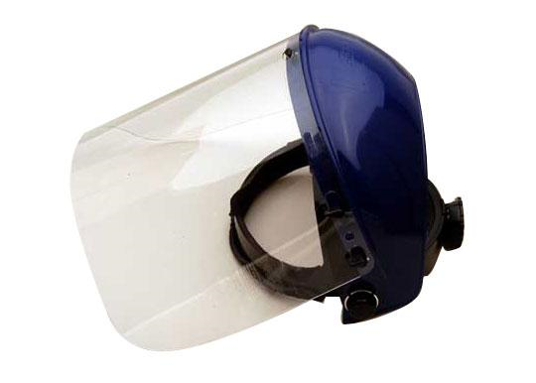

## Skin Protection

* Liquid resistant, loose–fitting cryogen rated gloves should be used for cryogen handling tasks. (Gloves should be loose-fitting so they are able to be quickly removed if cryogenic liquid is spilled on them).
* Enclosed footwear, non-cuffed long pants, and a lab coat should be worn when working with cryogens. The bottoms of the pants should cover past the tops of the shoes to ensure that no spilled cryogens can be accidently poured into the shoe.

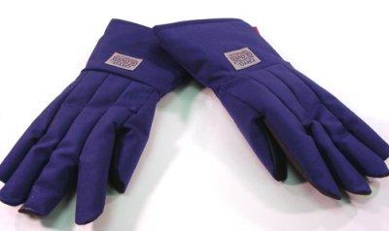 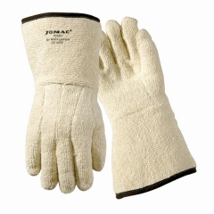

✓

# Vessels

## Pressure Relief

All vessels used for cryogens must have a pressure relief system to ensure that pressure cannot build up causing an explosion. Vents should be regularly checked to prevent ice build-up caused by water vapor.

A cryogenic liquid cannot be indefinitely maintained as a liquid even in well-insulated containers. If these liquids are vaporized in a sealed container, they can produce enormous pressures that could rupture the container. For this reason pressurized cryogenic containers are normally protected with multiple devices for over-pressure prevention. Common pressure-relief devices are a pressure-relief valve for primary protection and a rupture disc for secondary protection.



Figure 1: Typical Dewar with pressure relief device

All sections of equipment that may allow for the liquid to become trapped must be protected by a pressure-relief device as shown in Figure 2. The product vented by these relief devices should be routed to a safe outdoor location or a well-ventilated area.

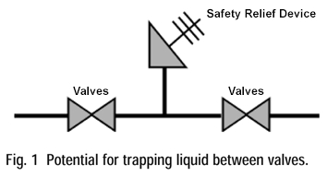

Figure 2: Potential for trapping liquid between valves

Vessels used for containing cryogenic materials must be specifically designed for that purpose. For example, a normal “thermos” flask for beverage storage is not appropriate.

# Filling

* Never leave filling operations unattended.
* Two persons should be present during all filling operations.

# Transport

## Small Volumes

* Inside buildings, from room to room, the best transport of liquid nitrogen (4 L and less) is to use a small Dewar which has carrying handles and a loose fitting lid or vent. This will allow the gas produced from the liquid boiling off at room temperature to escape.
* Cryogens must never be stored or transported in sealed containers. Thermos flasks with tight fitting lids are not suitable.

## Larger Volumes

* Larger volumes of liquid nitrogen should be transported using handcarts or wheeled Dewars.
* Lifting and carrying full liquid nitrogen Dewars, >25 liter is a two-person task, and should not be carried out alone.

Care must be taken when transporting wheeled containers. Wheeled containers must always be moved by *pushing the container rather than pulling it*. This reduces the chances of the container falling on top of you if it becomes unstable.

* A typical 180 L container weighs approximately 188 kg (260 lbs) when empty and 253 kg (556 lbs) when filled with liquid nitrogen.
* Never roll a cryogen container on its side.
* Always transport using a handcart.

## Elevator Transport

Only service elevators may be used; never transport a cryogen in a passenger elevator. *No personnel should accompany a cryogen Dewar in an elevator*. There is an asphyxiation risk from boil off in an enclosed space, especially if the elevator breaks down. It is recommended that two people work together to transport liquid nitrogen via the elevator.

* One person must be stationed on the relevant floor to receive the Dewar when the lift arrives.
* The second person places the Dewar in elevator selects the floor/level and exits the elevator before the doors close. The cryogen must travel unaccompanied. The first person removes the Dewar when it arrives.

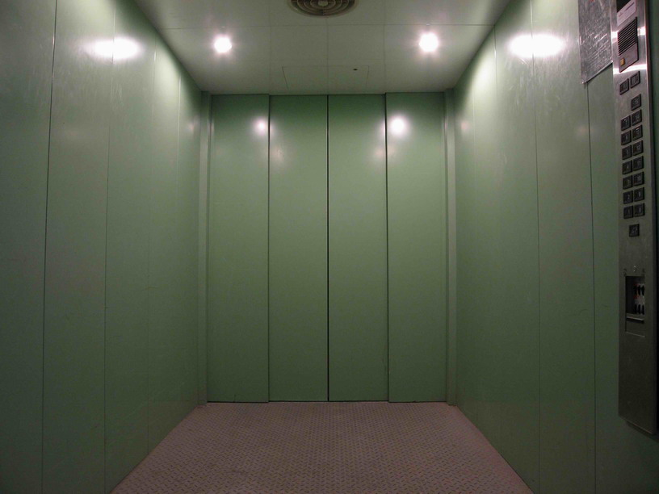

# Disposal

There are 3 methods for disposal of cryogenic liquids.

## Fume Hood

A container is placed in a fume hood and opened to allow the cryogenic liquid to evaporate. Both the horizontal and vertical sashes must be closed to prevent the gas from escaping into the laboratory. While contained inside the hood, the gas is exhausted directly out of the building. This method is reserved for small and medium containers.

## Open Air Evaporation

This method involves allowing the cryogenic liquid to evaporate outside in the open air. Following the transport procedure mentioned above, take the container to an isolated or designated area. Open the container to allow it to evaporate slowly. The container should be labeled following the labeling for [secondary containers guidance](https://hse.kaust.edu.sa/Services/PublishingImages/Pages/LFPsafetybulletins/Labeling_Secondary_Containers.pdf).

## Pouring

If the above options are not feasible, you may pour the liquid nitrogen in a dirt area or other designated area. Following the transport procedure, take the container to the designated dirt area. Slowly pour the cryogenic liquid onto the dirt careful not to cause any splashing.

Pouring requires 3 people; two people for transportation and pouring assistance. The third person will act as a first aider and make sure bystanders do not enter the pouring area. Everyone involved in the procedure must wear the personal protective equipment mentioned in this guidance. This procedure must be performed during low pedestrian traffic to minimize the chance of others walking into the area (morning or late afternoon).

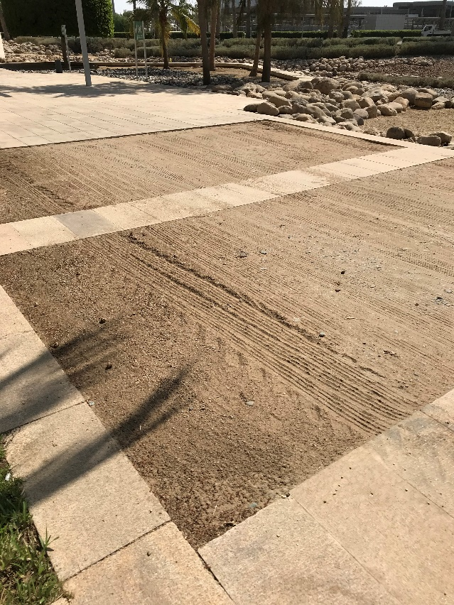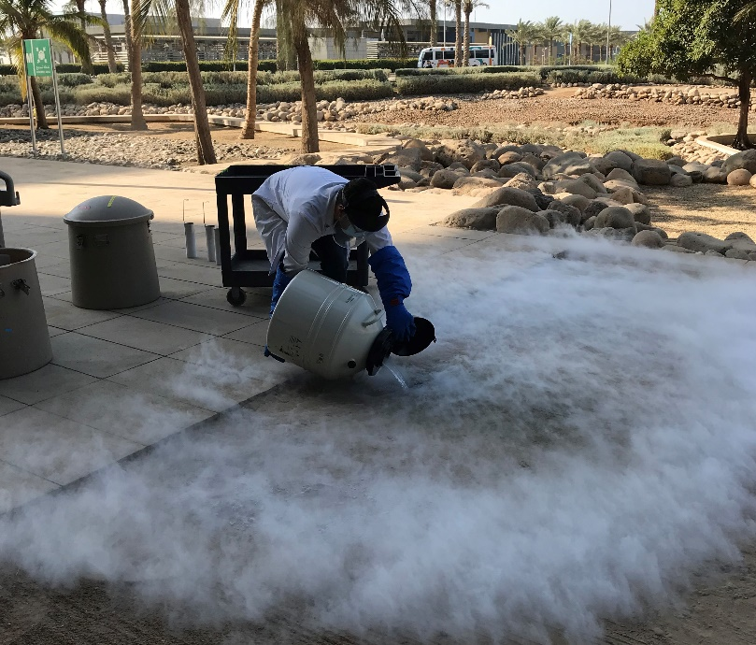

Dirt areas behind buildings 2,3,4,5

Slow and controlled pouring

# First Aid and Emergency Procedures

## Cold Burns

* Flush the area with warm (not hot) water for 15 minutes.
* Obtain first aid assistance.
* Prolonged contact will cause skin to blister and will require medical treatment.
* Cryogens penetrate clothing much more quickly than water, so remove any contaminated clothing immediately.

## Asphyxiation

* If you suspect that someone is suffering from asphyxiation, do not enter the affected area to attempt rescue – an oxygen deficient atmosphere may be present.
* Call 911 (02-808-0911 from a mobile). Rescue should only be made by those trained in the use of self-contained breathing apparatus.

Note: The minimum permissible oxygen concentration is 19.5% - anything less than this is considered oxygen deficient.

Note: Cryogenic gases are colorless and odorless. **Fog clouds do not define the gas cloud**. They define the area where the vapors are cold enough to condense the moisture in the air. The gas cloud can extend well beyond the fog cloud depending on the product and atmospheric conditions. Although fog clouds may be indicative of a release, they must never be used to define the leak area and should not be entered by anyone. The dense fog clouds associated with the handling or transfer of cryogenic liquids can obstruct visibility. Care should be exercised so that any clouds do not interfere with vehicle traffic or safety escape routes.

## Spills

* Minor spill (< 1 liter) ‐ allow liquid to evaporate, ensuring adequate ventilation. Following return to room temperature, inspect area where spillage has occurred. Report any damage to floors, walls, equipment.
* Major release (> 1 liter) ‐ evacuate area of all personnel and make sure persons do not re-enter the area. Call 911 or 028080911. Prevent re-entry to the area until it has been declared safe.
* Do not flush spilled liquid into sewer or storm drains.