Guidelines for Working with Corrosive Chemicals

# Executive Summary

Corrosive materials are substances that “cause irreversible tissue damage to human tissue”. Human tissues to be damaged from corrosive materials are not only limited to eyes and skin but also to the respiratory tract through inhalation and gastrointestinal tract through ingestion.

Corrosive materials not only damage human tissue but also corrode metals and some other materials and can be further classified into either acidic or basic (caustic or alkali) materials. Acidic corrosives have a low pH (pH 0-5) whereas basic corrosives have a high pH (pH 11-14). ***Note:*** *pH values are on a logarithmic scale and not linear.* More so than other hazard class, corrosive materials chemically and readily react with many other materials. This reactivity adds another dimension to the hazard profile of corrosive materials, for they can react (aka chemical incompatibilities) to create other hazards in the form of explosive and toxic materials as well as generate heat and pressures.

This reactivity explains why corrosive materials are a ubiquitous and widely used hazard class in many settings (home use, kitchens, etc) and not just laboratories. Their functionality and usefulness dictates it. This ubiquitous and widely used status of corrosive materials helps explain the concern of why many people need to be aware of its destructive and hazardous nature and the precautions necessary to protect one’s health and safety but also of their equipment as well.

Watch the videos below showing the corrosive effect of acids and bases on materials as well as an overview of corrosive material injuries.

<https://www.youtube.com/watch?v=WnPrtYUKke8>

<https://www.youtube.com/watch?v=fnDhA5gtjCY>

**Key take away points for working with Corrosive materials**

* Know what PPE will protect you – your eyes, skin, and life may very well depend on it!
* Know how to clean up a corrosive material spill before working with it.
* Work with corrosive materials as much as possible in well ventilated areas; a chemical fume hood or glove box is most preferable.
* Know where the nearest emergency shower, eye wash and sink are. The ability to quickly wash off exposures from corrosive materials goes a long way in protecting your health and well-being. **Emergency showers and eye washes are required when working with corrosive materials!**
* Know how to safely store corrosive materials and what materials they are incompatible with, especially during the disposal of the corrosive materials. **Store acids separately from bases!**
* Always thoroughly clean up equipment and work areas when finished working with corrosive materials to prevent chemical exposures from accidental contact.
* All corrosive materials attack metal.
* Some hydroxides etch glass.

**Important considerations and issues**

* Do these procedures require prior approval (i.e. PI approval) before work begins?
* Do these guidelines apply to all of the PI’s laboratories or specific ones?
* Is this document guideline alone sufficient or are other reference materials required? e.g. equipment manuals, reading background information, etc.
* Is there any prerequisite training before work is to begin with this type of material? e.g. basic compressed gas work, operating equipment or instruments, etc.
* Have you done a thorough risk assessment before working with this type of material?
* Any special First Aid issues while working with these types of materials?
* Any special tips, tricks, advice or comments to add? If so, then edit this document and add it.

# Overview of Hazards (Hazard Awareness)

According to the Occupational Safety and Health Administration (OSHA), *Corrosive materials* are chemicals that cause visible destruction of, or irreversible alterations in, living tissue by chemical action at the site of contact. Researchers utilizing corrosive materials **must** read and understand manufacturer’s Safety Data Sheet (SDS) prior to commencing work with such materials.

Characteristics and requirements of corrosive materials include:

* May have very low pH (acids) or very high pH (bases, caustics or alkalis).
  + Note: Corrosive materials that are basic are also known by other terms such as caustic or alkali. Throughout the rest of this document these materials will be referred to as “base/basic” due to the prevalence of this descriptive term especially throughout science labs.
* May react with incompatible chemicals to produce heat, gas or fire.
* May cause burns upon contact with skin.
* May have the following symbols and/or labelling.

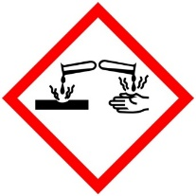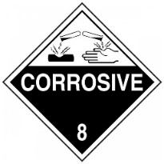

* May appear in the Specific Hazard section (white) of the NFPA 704 diamond (below) as a: Acid, Alkali, or Corrosive;

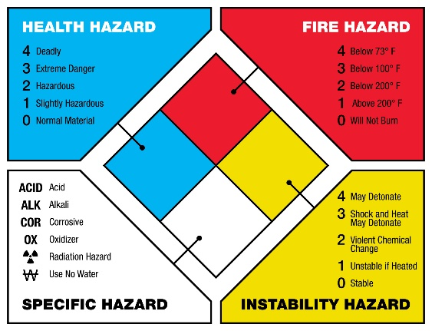

* Should be stored in a corrosive cabinet.
* Often dissolved in water – generally not flammable.
* May corrode or degrade other materials upon storage, including the corrosive materials own container and cap over time. Example, see image below.

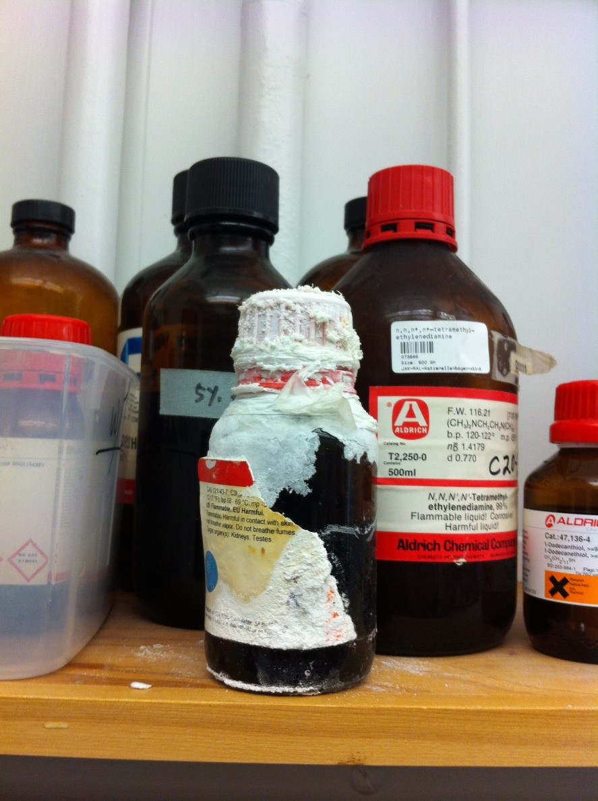

**Tip: How do you tell the difference from an acid or base?**

Knowing whether a chemical is a corrosive is not enough, many times a person must make the determination if a material is acidic or basic. This is especially true when storage decisions have to be made – is the material an acid or a base?

Acids many times have the name “acid” in their name. Materials such as benzoic acid, hydrochloric acid, sulfuric acid, etc illustrate this point. Basic materials many times in turn may have the name “hydroxide” in the chemical name. Materials such as lithium hydroxide, sodium hydroxide, potassium hydroxide illustrate this point as well but for basic corrosive materials.

But not all corrosive materials neatly have these descriptors in their name. Thionyl chloride (SOCl2) and bleach are two good examples. In cases such as this, many times acidic corrosive materials usually have halogen atoms (fluorine, chlorine, bromine, iodine) present. Examples: thionyl chloride (SOCl2), phosphoryl chloride (POCl3), etc. For corrosive basic materials, usually the presence of an alkali metal (lithium, sodium, potassium, etc) indicates a corrosive material is basic. Examples: bleach, n-butyl lithium, methyl lithium, etc.

Further, in the following sections of an SDS one may find good information to make a determination if a corrosive material is acidic or basic.

* SDS Section 7: Handling and storage
* SDS Section: 9: Physical and chemical properties – pH in particular
* SDS Section 10: Stability and reactivity

If the above mentioned methods fail to give you the information needed to make an informed decision concerning if a corrosive material is acidic or basic, ask experienced personnel in your laboratory or contact [hse@kaust.edu.sa](mailto:hse@kaust.edu.sa).

Table of representative acidic and basic corrosive materials (solids, liquids, gases).

**Note:** This list is not exhaustive

|  |  |
| --- | --- |
| Corrosives (acidic) | Corrosives (basic) |
| Liquids | |
| Acetic acid | Ammonium hydroxide |
| Bromine | Pyridine |
| Hydrochloric acid | Bleach |
| Hydrogen peroxide | Tetramethylammonium hydroxide |
| Trifluoroacetic acid |  |
| Solids | |
| Benzoic acid | Sodium hydroxide (pellets) |
| Trinitrophenol (picric acid) | Potassium hydroxide (pellets) |
| Phenol | Lithium hydroxide (solid) |
| Gases | |
| Hydrogen chloride | Ammonia |
| Hydrogen cyanide |  |
| Chlorine |  |
| Fluorine |  |

**Identification Tip**

Many bulk corrosive chemicals have color coded caps. **Note of caution:** Not every manufacturer color codes their corrosives in this manner.

* Red cap – Nitric acid
* Blue cap – Hydrochloric acid
* Yellow cap – Sulfuric acid
* Brown cap – Acetic acid
* Green cap – Ammonium hydroxide

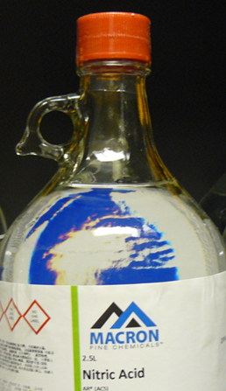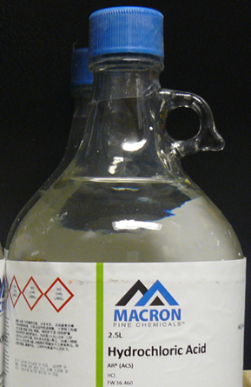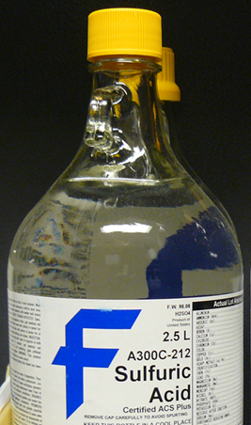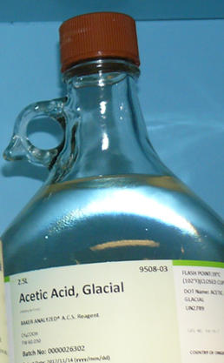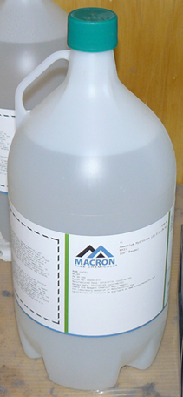

**Examples of Corrosives used in** *Insert PI’s Name Here* **group lab.**

*PIs and Lab managers: enter Corrosives used in your lab in this section.*

|  |  |  |
| --- | --- | --- |
| **Corrosives Name & Formula** | **CAS #** | **Location** |
|  |  |  |
|  |  |  |

# Engineering Controls and Safe Work Practices

* All work utilizing corrosive materials should be done in a properly operating chemical fume hood, glove box, or appropriate engineering control with emergency spill kits accessible and nearby. *Glove boxes and chemical fume hoods are preferred.*
* Be sure all equipment being utilized is compatible with the corrosive material being used. Example: Glassware is incompatible for working with hydrofluoric acid.
* De-clutter and remove from work area any incompatible material that is not necessary.
* Inexperienced users of corrosive materials must be supervised while performing experiments.
* Always thoroughly cleanup equipment and work area when finished to prevent chemical exposures from accidental contact with corrosive materials. This also helps to prevent damage and corrosion to equipment such as compressed gas regulators, reusable needles, etc.
* To prevent spills, don’t use vessels near their maximum volume capacity.
* Manipulation of corrosive liquids via syringe should utilize locking mechanisms (luer locks, etc.) and have apparatus connections clamped (keck, etc.) when appropriate.
* When syringing corrosive liquids, use 16-18 gauge needles of ~8-12” (20-30 cm) in length (24” or 60 cm for cannula) to reduce occurrences of plugged needles.
* Never use a syringe at its maximum volume. Syringe plungers can quickly “pop-out” near their maximum volume. Examples; If you need 5 mL of reagent, use a 10 mL syringe. Need 25 mL of reagent, use a 40 mL syringe. If you need >50 mL of corrosive liquid use a graduated cylinder, cannula, double-tipped needle or use multiple smaller withdrawings *via* syringe.
* Be sure all tubing is in good condition and free of holes, cracks, corrosion or any other defects that would compromise the integrity of the system utilizing the corrosive gas.
* Use bottle carriers (see picture below) or a cart (with corrosive material in a secondary container) for transporting liquid corrosive materials.

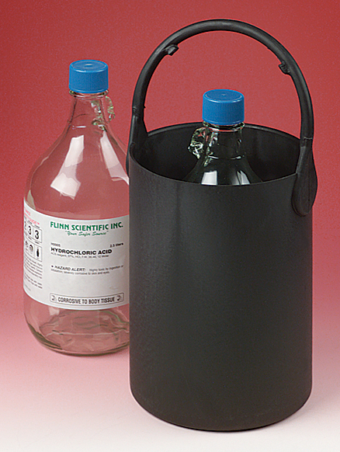

* If using pipettors for measuring corrosive liquids, be sure it is resistant to corrosion, especially the plunger.

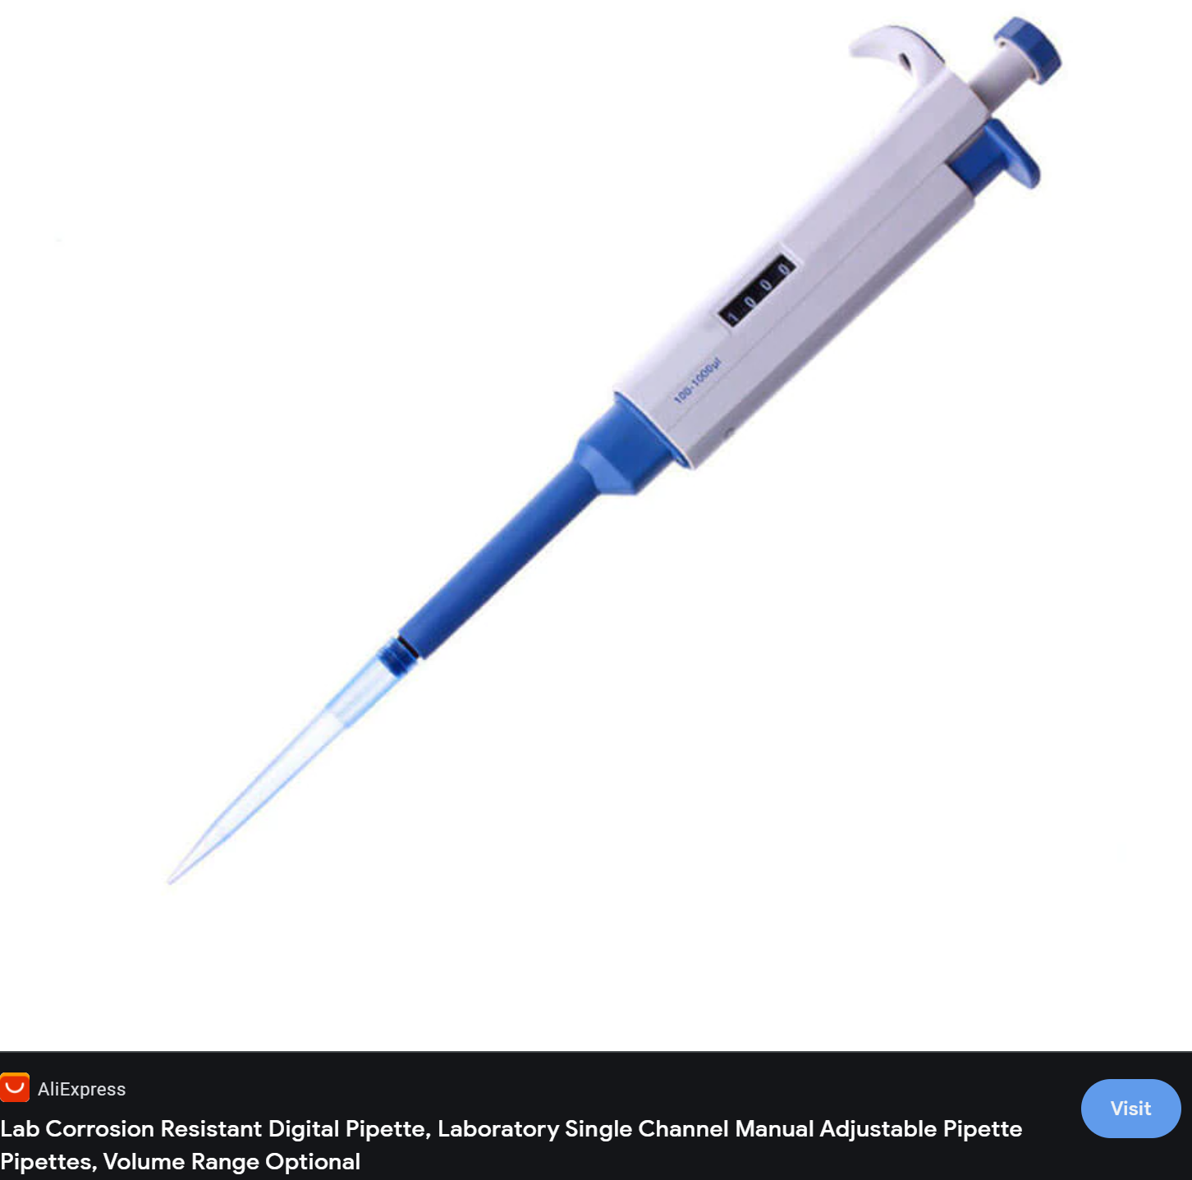

* Don’t use bench paper with corrosive materials.

**Examples of septa that maybe required for working with corrosive liquids. Septa help with maintaining a sealed enclosure but still allow for the addition and withdrawal of material via needle-syringe.**

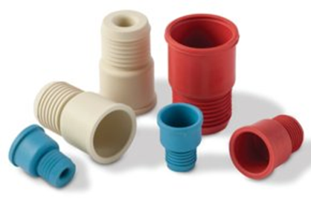 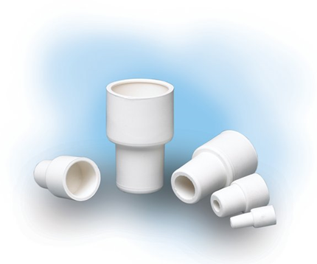

**Safe Work Practices for Solid Corrosive Materials**

Techniques for manipulating corrosive solids are the same as for other standard solids (as taught in standard chemistry lab classes) with three exceptions: Ventilation, PPE and thorough cleanup. Ventilation and PPE are of critical importance to reduce exposure to corrosive materials and must be used whenever possible. Once the manipulation of corrosive solids is completed, a thorough cleanup of all equipment and lab space (e.g. scales, counter tops, etc) is prudent to reduce chemical exposures to lab personnel and to avoid damage to lab equipment via corrosion.

**Safe Work Practices for Liquid Corrosive Materials**

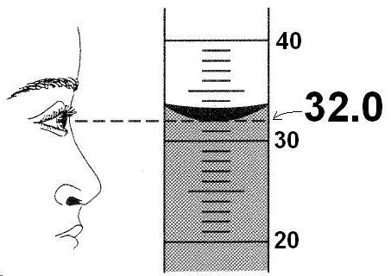

**Proper way to measure liquid: read the liquid level at the bottom of the meniscus with measuring device vertical and at eye level.**

**Corrosive Liquids – Syringe Technique**

1. Clamp bottle of reagent to a solid support to prevent unnecessary movement. If bottle is coming from cold storage and is stable at ambient temperature, allow it to come to ambient temperature first.
2. Remove screw-cap from reagent bottle and insert inert gas line needle into septa to place reagent contents under low positive pressure.
3. Purge a needle/syringe combination with inert gas a few times. Insert needle (with syringe attached, locked and plunger fully forward) into reagent bottle through septa until needle comes near the bottom of the reagent bottle.
4. Draw the reagent out slowly (to avoid air bubbles) with the syringe pointing downward until a small excess of reagent is withdrawn.
5. Now flip the syringe so that it is pointing upward and gas in syringe is allowed to rise. With the syringe still pointing upward, push on plunger until the exact volume of liquid is desired.
6. Now, with syringe still pointing upward, bring the tip of the needle out of the liquid reagent until it is in the headspace of the reagent bottle (headspace is the gas filled portion of the reagent bottle above the liquid), then slowly pull the plunger back to bring in inert gas as a head space inside of the syringe.



1. With the syringe still pointing upward, pull the needle out of the septa of the reagent bottle but leaving the inert gas needle in place.
2. Now, with the syringe still pointing upward, insert the needle into the septa of the reaction apparatus that has already been setup. Slowly push the plunger of the syringe inward until it stops and then remove the needle from the septa of the apparatus.
3. At this point you may rinse the syringe and needle with a solvent that is the same or compatible with the solvent the corrosive liquid was dissolved in. Do this by inserting needle tip into a flask of the solvent (twice the volume of the syringe) slowly ejecting and injecting the solvent from the syringe. Then rinse with water and clean as normal.

**OR**

If the syringe is disposable, just quench with water by quickly injecting and ejecting water out of the syringe and needle. Then clean as normal.

1. Once done, be sure reagent bottle is still under an inert atmosphere, withdraw needle from inert gas manifold and recap the reagent bottle. Be sure to use parafilm, bakelite caps or other means to ensure corrosive liquid remains under inert atmosphere. Place reagent bottle back into its appropriate storage location.
2. Cleanup equipment and the work surface in the appropriate manner.

**Corrosive Liquids – Pipette Technique**

The technique below can also be utilized with a mechanical or electronic pipettor by omitting the compressing/decompressing of the bulb with precise drawing and releasing of the liquid via pipettor controls.

1. Remove cap from reagent bottle and insert pipette with bulb that has been compressed.
2. Decompress bulb and allow corrosive liquid to be drawn up into the pipette until an excess of the desired liquid has been reached.
3. Now manipulate the bulb (compressing and decompressing) until the desired level of corrosive liquid has been obtained.

**OR**

If an analytical pipette is being utilized, remove the bulb and quickly stopper the bulb end of the pipette. Manipulate the bulb end opening with a finger/thumb, allowing excess liquid to drain out of the pipette until the desired liquid level is obtained.

1. Transfer the pipette of corrosive liquid to the intended vessel and expel the corrosive liquid from the pipette.
2. Close the reagent bottle and place it back into its proper storage location.
3. Cleanup equipment and the work surface in the appropriate manner.



**Corrosive Liquids – Graduated Cylinder Technique**

1. Place graduated cylinder on a level and stable surface.
2. Remove cap from reagent bottle and place a funnel in the mouth of the graduated cylinder.
3. With the lip of the reagent bottle in direct contact with the funnel, pour the corrosive liquid into the graduated cylinder until the liquid level reaches the desired level. You may need to use a Pasteur pipette to get the exact desired level of corrosive liquid.
4. Once the desired amount of corrosive liquid is obtained in the graduated cylinder and with the lip of the graduated cylinder in direct contact with the funnel of your vessel, slowly pour the graduated cylinder contents into the desired vessel.
5. Close the reagent bottle and place it back into its proper storage location.
6. Cleanup equipment and the work surface in the appropriate manner.

**NOTE:** When diluting concentrated corrosives with water, always add the concentrated corrosive to the water and never vice-versa. Concentrated corrosives tend to have a greater density and don’t allow added water to mix well. This causes exothermic hot spots and possible “popping”. Adding the concentrated corrosive to water alleviates this effect.



# Personal Protective Equipment (PPE)

In addition to the minimum PPE set forth in [PPE Standard for KAUST Laboratories](https://hse.kaust.edu.sa/Services/PublishingImages/Pages/labsafety/PPE_Standard_For_KAUST_Laboratories.pdf), researchers need to select any additional PPE (below) that should be utilized. See SDS section 8 (Exposure Controls/Personal Protection) or [KAUST laboratory Safety Manual](https://hse.kaust.edu.sa/Services/Pages/LabSafetyManual/Introduction.aspx) for more information.

Gloves: disposable  double gloving chemically resistant insulated

Eye wear: goggles safety glasses face shield (for splash hazards)

Lab coat: cotton flame resistant  apron

Respirator: Filter cartridge type:________________________

*Respirator usage requires enrolling in the [Respiratory Protection Program](https://hse.kaust.edu.sa/Services/Pages/respiratoryprotectiontraining.aspx)

other____________________________

**Respirator usage is optional! –** Engineering controls should be used as much as possible when working with corrosive materials. If you believe your current engineering controls are not sufficient and a respirator is needed, see [Respiratory Protection Program](https://hse.kaust.edu.sa/Services/Pages/respiratoryprotectiontraining.aspx) for further information regarding possible respirator usage.Further, due to the destructive nature corrosive materials may pose it may be prudent or necessary to utilize special respiratory equipment (e.g. filters) designed for the use with corrosive materials.

**Special Note:** In the *SALUTE* Chemical Inventory, SDSs are available from *Chemwatch*. In *Chemwatch*’s SDS, section 8 has a computer generated material selection guide for gloves which can be extremely useful for unusual chemicals that are not available on many glove selection charts. Below is for thionyl chloride.

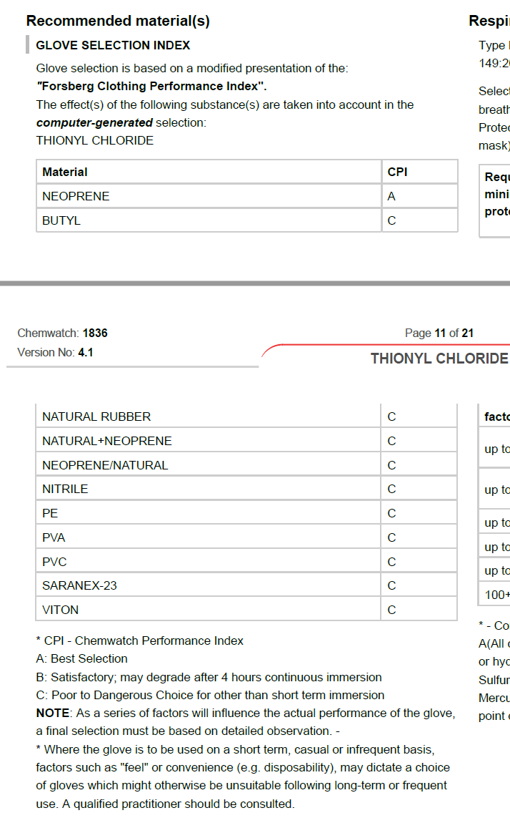

# Storage

Corrosive materials must be stored:

* Always with the utmost of care with acids being separated from bases.
* In a secondary container, if possible.
* According to manufacturers’ SDS.
* With quantities kept to a minimum.
* In a compatible manner with other reagents. **IMPORTANT:** Avoid acid storage with alcohols, azides, bases, bleach, cyanides, sulfides, nitrides, carbides, and metals.
* Preferably in a corrosive resistant material cabinet.

**NOTE:** All corrosive materials attack metal! Some hydroxides etch glass!

**NOTE:** Some corrosive materials are also strong oxidizers and must be stored away from organic materials. Examples include Hydrogen peroxide, Chromic, Nitric, Perbromic, Perchloric, and Periodic acids.

*Determine the most dangerous hazards (explosions, fires, toxic gas generation, etc) and make it a priority to prevent those first!*

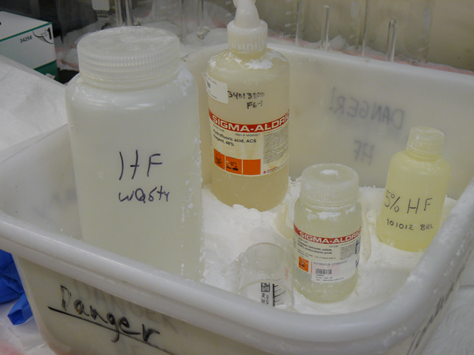

Ideal storage for Hydrofluoric acid – notice calcium carbonate powder in secondary container to neutralize excess HF that may drip down sides of bottles.

Below are examples of acids and bases being incorrectly stored together in the same cabinet. Notice the formation of solid salts on the lids. Storing acids and bases in the same cabinet in secondary containers does not prevent the interaction of the vapors from reacting – one must store them in separate cabinets!

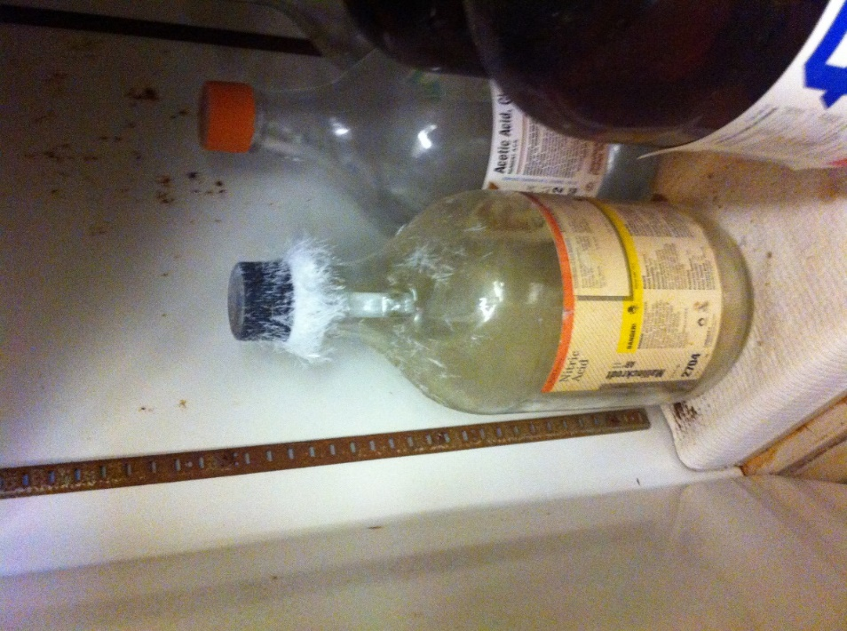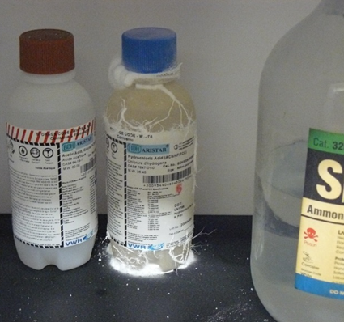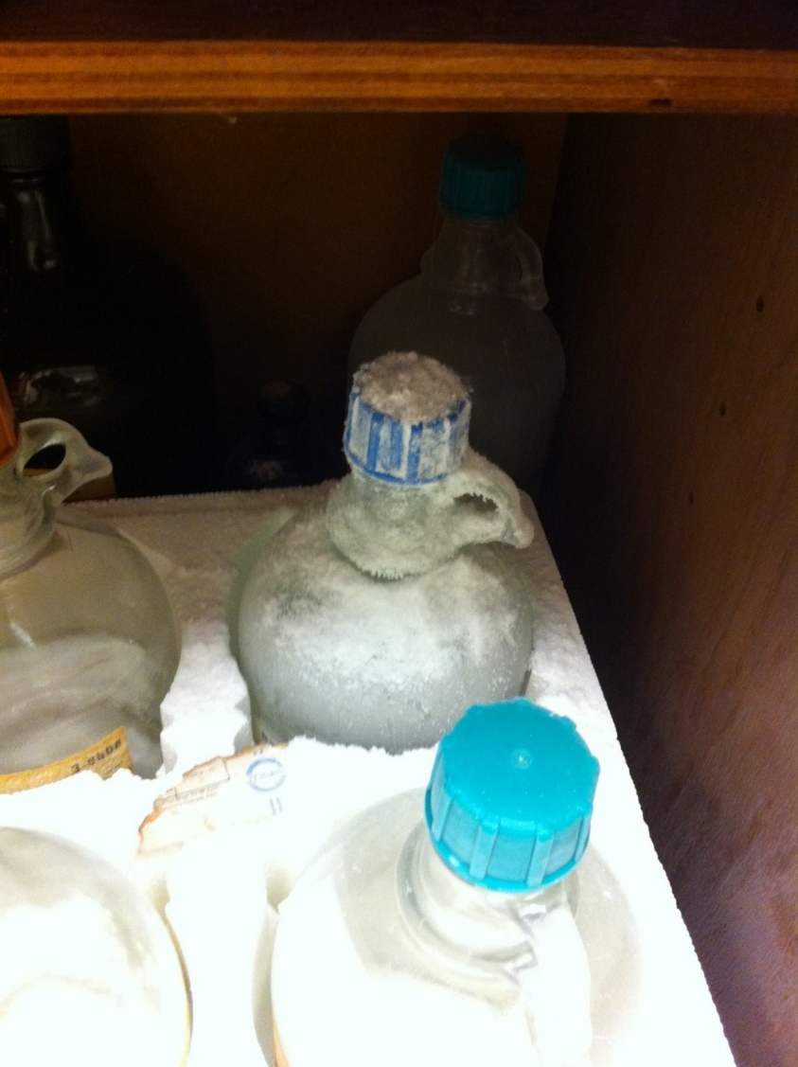

Below is an example of a telltale sign that a corrosive material is present in a cabinet – rusted and corroded metal.

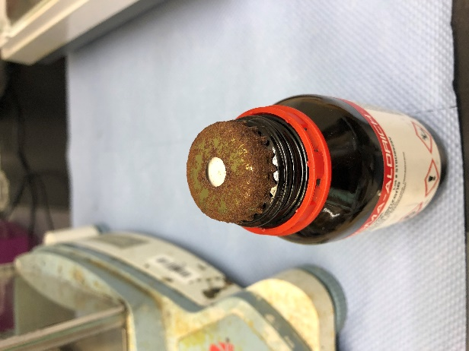

# Emergency Procedures

**Spill kit for corrosive materials**

An ideal spill kit for corrosive materials should be composed of the following;

* Chemically resistant gloves
* 3-5 Kg of acid neutralizer (sodium bicarbonate for general acid use, calcium carbonate for hydrofluoric acid*).

<https://www.youtube.com/watch?v=udYh-HWS5LU>

* 3-5 Kg of base neutralizer (citric acid, tartaric acid or sodium bisulfate).
* Sealable plastic bags (ziplocs)
* Dust pan and whisk broom
* 5 gallon plastic pail with lid

*\*Neutralizing hydrofluoric acid with sodium bicarbonate will still produce a highly toxic and water soluble compound (sodium fluoride), whereas neutralizing with calcium carbonate will produce a dramatically less water soluble compound (calcium fluoride) that is non-toxic due to its lack of water solubility.*

Place all listed materials in a 5 gallon pail and label the pail “Spill Kit”. Place spill kit in an easily accessible location where all lab personnel are aware of. All lab personnel should be [trained](https://hse.kaust.edu.sa/AwarnessEngagementAndTraining/Pages/Research-Classroom-Training.aspx) to handle spills of the materials they are working with before they begin lab work.

**Incidental Spills**

To use spill kit, first don personal protective equipment (PPE) of chemically resistant gloves, lab coat, and safety glasses. If necessary (and if available) use a respirator as well. If corrosive material is a:

* **Solid –** use whisk broom and dust pan to carefully cleanup corrosive solid. Then place material in plastic bags or pail.
* **Liquid** – sprinkle the appropriate neutralizer on all surfaces exposed to the corrosive material. Start from the outside edges of the spill and work your way to the middle. Slowly keep adding neutralizing agent until the spilled corrosive material stops reacting to the neutralizer. Stir the combined materials thoroughly and let stand for 5-10 minutes and then proceed to cleanup spill by placing material in plastic bags or pail.

Seal the waste bags or pail, store in a safe manner and submit as hazardous waste for disposal. Carefully and thoroughly wash spill area with soap and water. Dispose of all soiled spill material through the KAUST hazardous waste program (see **Hazardous Waste** **Disposal** section).

**Major Spills**

If an unmanageable spill of corrosive material happens inside the fume hood, close the sashes of the chemical fume hood. Immediately evacuate the laboratory and call 911 (landline) (012-808-0911 from cell phone) to alert emergency responders.

If an unmanageable spill of corrosive material happens outside the fume hood, immediately evacuate the laboratory and call 911 (landline) (012-808-0911 from cell phone) to alert emergency responders. Place signage on door alerting others not to enter laboratory.

**First Aid**

Rinse off exposed areas with large quantity of water for 15 minutes and remove any contaminated clothing. If it is during regular work hours, inform the PI or supervisor, and seek medical assistance immediately. Call 911 (landline) (012-808-0911 from cell phone) for life threatening exposure.

**Special First Aid notes:**

Hydrofluoric acid – If the exposure is a hydrofluoric acid exposure, be sure to inform dispatch personnel it is such and immediately apply calcium gluconate after flushing exposed area with large quantity of water.

**Note:** Calcium gluconate kit is mandatory if hydrofluoric (HF) acid work is being conducted. Be sure to examine the expiration date (circled below) periodically on the end of the calcium gluconate tube.

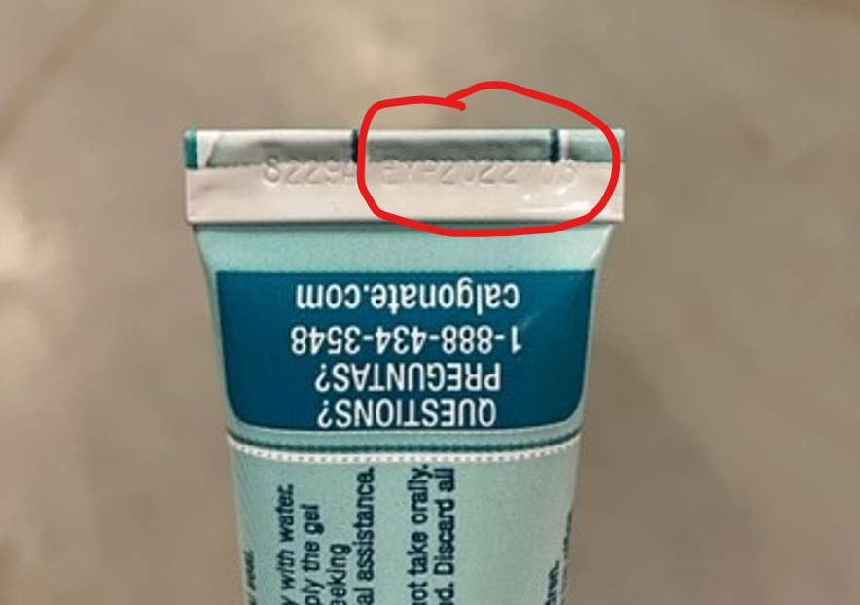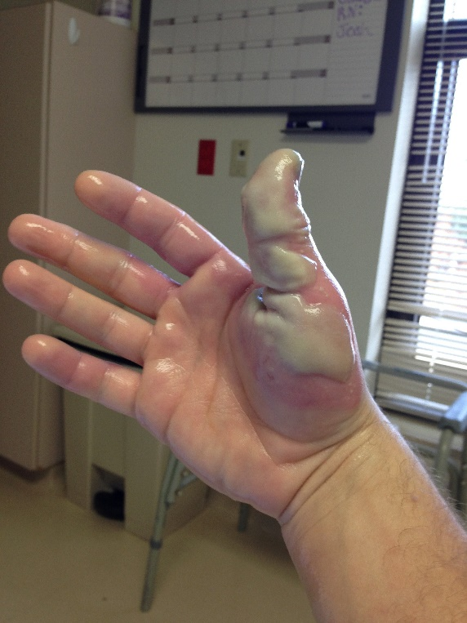

**Equipment**

When preparing to work with corrosive materials, emergency equipment must be present before work is to commence. **Be aware of emergency equipment location!**

* Emergency eye-wash – test before using corrosive materials. Make sure eye wash station access is unobstructed.
* Emergency shower – use chemical fume hood closest to shower if possible. Make sure emergency shower access is unobstructed.
* Chemical fume hood (to help vent corrosive vapors out lab space) – chemical fume hood must be working properly and have been de-cluttered.
* Fire alarm – identify where pull stations are in case you need assistance with an emergency.

**IMPORTANT NOTES:**

**Before work begins –** You must know how to clean up any spill or leak of a material before working with it! Be sure to have enough of the cleanup material before hand as well.

**Comfort level** – Only the person cleaning up the spill should make the decision of whether the spill is too large for them to safely clean up.

**Emergency shower and eye washes –** Emergency showers and eye washes are required when working with corrosive materials.

# Hazardous Waste Disposal

Upon completion of working with corrosive materials, dispose of material;

* In an appropriate constructed container and clearly labelled as to the contents, hazards and generator information in accordance to the [hazardous waste training](https://hse.kaust.edu.sa/training/research-safety-training) and [Hazardous Waste Manual](https://hse.kaust.edu.sa/docs/default-source/research-safety/hazardous-waste-manual.pdf?sfvrsn=a356debe_2).
* Submit for disposal utilizing the established proper channels and methods outlined in the KAUST [Hazardous Waste Manual](https://hse.kaust.edu.sa/docs/default-source/research-safety/hazardous-waste-manual.pdf?sfvrsn=a356debe_2).
* Notify HSE ([hse@kaust.edu.sa](mailto:hse@kaust.edu.sa)) if you have further questions or visit the [hazardous waste webpage](https://hse.kaust.edu.sa/services/research-laboratory-hazardous-waste).

# Training and Documentation

Training conducted by (print name):____________________________________________

Trainers signature and date:__________________________________________________

Training venue and method. Check all that apply: Classroom/lab lecture

One-on-one Demonstration Hands on Experience SOP review

|  |  |  |
| --- | --- | --- |
| **Date** | **Name** | **Signature** |
|  |  |  |
|  |  |  |
|  |  |  |
|  |  |  |
|  |  |  |
|  |  |  |
|  |  |  |
|  |  |  |
|  |  |  |
|  |  |  |
|  |  |  |
|  |  |  |
|  |  |  |
|  |  |  |
|  |  |  |
|  |  |  |
|  |  |  |
|  |  |  |
|  |  |  |
|  |  |  |
|  |  |  |