Guidelines for Working with Corrosive Chemicals – Chromic acid

This document is an addendum to *Guidelines For Working With Corrosive Chemicals* (C-1) and is offered to provide a short and concise overview of a widely used and unique hazardous corrosive material. Understanding of the parent document is a crucial perquisite in understanding basic safety fundamentals such as 1) hazard awareness, 2) engineering controls, 3) work practices, 4) PPE and 5) emergency response for working with corrosive materials.

**Chromic acid**

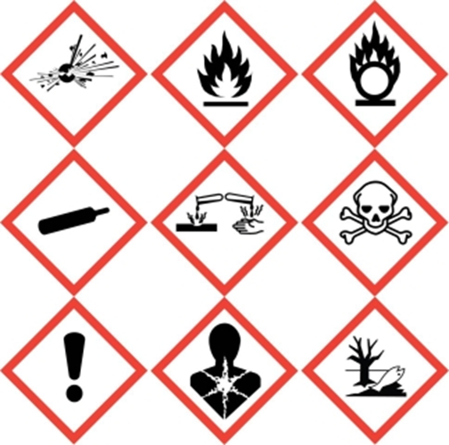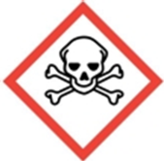 

Chromic acid (H2CrO4) is not only a highly corrosive material it is a strong oxidizer, toxic and carcinogenic material as well. Therefore not only will one need to follow the basic precautions of working with corrosive materials as detailed and outlined in the preceding pages but one will need to follow basic guidelines of working with oxidizers and Particularly Hazardous Substances (PHS) as well.

Chromic acid is usually created in the lab by dissolving a salt form of dichromate in concentrated sulfuric acid and has a very distinctive dark red/orange color due to the Cr+6/Cr(VI) ion (hexavalent chromium). Chromic acid has many niche uses in the lab from electroplating, anti-corrosion uses (the element Chromium is corrosion resistant), organic synthesis and even for the cleaning of glassware when glassware surfaces must be extremely clean for analytical purposes. Chromic acid as well as some of its derivatives (Jones and Collins reagent, pyridinium chlorochromate [PCC], etc) are also very useful for the oxidization of organic compounds such as alcohols.

However the Cr+6 ion is extremely toxic and carcinogenic, such work must be done under good exhaust ventilation. Correct PPE usage is also critical with PVC being the best material for the chromate ion.

**Tip:** Since the Cr+6 ion is distinctively dark red/orange its destruction/diminishment (via reduction) to Cr+3 can be detected by the disappearance of this dark red/orange color.

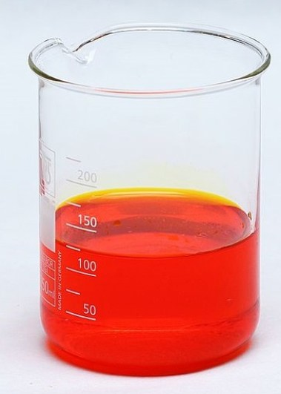

**Key take away points for chromic acid (in addition to the already stated for Corrosive Materials)**

* Never clean up spills of chromic acid with spill pads or paper towels. Neutralize chromic acid first.
* Store chromic acid away from organic materials (organic acids). Use secondary containers if you must store chromic acid with organic acids.
* Never mix chromic acid with organic materials unless you are purposefully trying to oxidize it.
* Be especially careful that chromic acid waste is disposed in a container free of organic residue.
* Chromic acid (and many of its derivatives) are toxic and carcinogenic. Treat them similarly as other particularly hazardous substances (PHS) – use under exhaust ventilation and PPE use is critical!

**Training and Documentation**

Training conducted by (print name):____________________________________________

Trainers signature and date:__________________________________________________

Training venue and method. Check all that apply: Classroom/lab lecture

One-on-one Demonstration Hands on Experience SOP review

|  |  |  |
| --- | --- | --- |
| **Date** | **Name** | **Signature** |
|  |  |  |
|  |  |  |
|  |  |  |
|  |  |  |
|  |  |  |
|  |  |  |
|  |  |  |
|  |  |  |
|  |  |  |
|  |  |  |
|  |  |  |
|  |  |  |
|  |  |  |
|  |  |  |