Guidelines for Working with Corrosive Chemicals – Base baths

This document is an addendum to *Guidelines For Working With Corrosive Chemicals* (C-1) and is offered to provide a short and concise overview of a widely used and unique hazardous corrosive material. Understanding of the parent document is a crucial perquisite in understanding basic safety fundamentals such as 1) hazard awareness, 2) engineering controls, 3) work practices, 4) PPE and 5) emergency response for working with corrosive materials.

**Base baths**

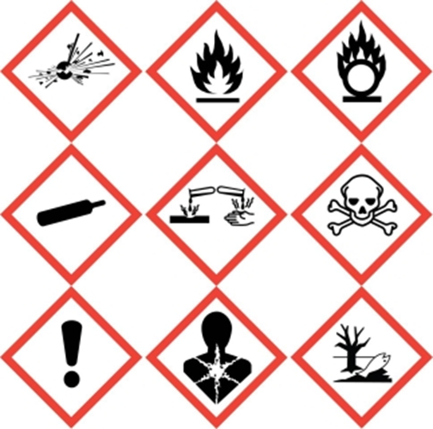  

Bath baths are not only a highly corrosive materials but usually flammable as well. Therefore not only will one need to follow the basic precautions of working with corrosive materials as detailed and outlined in the preceding pages but one will need to follow basic guidelines of working with flammable liquids as well.

Base baths are typically a mixture of sodium or potassium hydroxide in ethanol or isopropanol and is used for the cleaning of laboratory glassware of organic residues (not metals). Due to the presence of flammable liquids in base baths it is critical to remember that base baths must be handled with the same measures as that of other flammable liquids; avoid ignition sources such as electrical outlets/switches, open flames, sparks, heat sources, etc. Since glassware will be submerged in the base bath, use tongs to retrieve glassware along with long, heavy duty neoprene gloves due to this type of work where hands will be submerged as well as the high splash hazard.

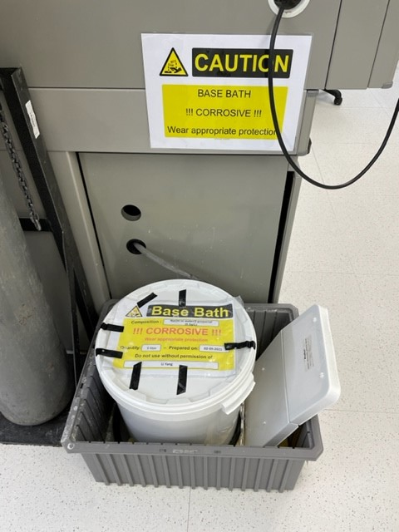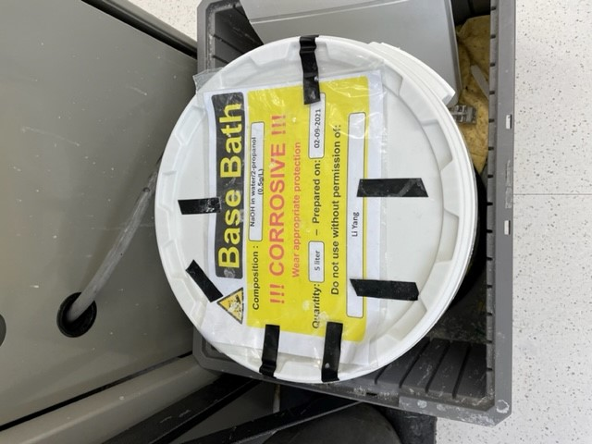

<https://www.youtube.com/watch?v=0wHWlwuQ2eY>

When base baths become orange or darker, it is time to change it out by making a new base bath mixture. Since base baths do tend to have a degrading effect upon plastic containers, many times it is best just to replace the plastic base bath container when the bath needs to be changed. This is to minimize the chance that the base bath container will create a spill hazard via cracked plastic. However the base bath contents must be placed in a small necked waste container as wide mouth containers (such as buckets or small drums) are not suitable for liquid hazardous waste.

**Key take away points for base baths (in addition to the already stated for Corrosive Materials)**

* Clean up spills of a base bath with spill pads first as the flammable hazard is critical to get under control. Neutralize the remaining residue second with an organic acid (citric, malic, tartaric acids).
* Store base baths away from acidic materials as well as away from any ignition source such as open flames, sparking devices, heat sources, electric outlets, etc.
* Keep base baths containers closed as much as possible – it is flammable!
* When base baths become orange or darker, it is time to change out the base bath and make a fresh mixture.
* The best gloves for base bath work are long, heavy duty neoprene gloves.

**Training and Documentation**

Training conducted by (print name):____________________________________________

Trainers signature and date:__________________________________________________

Training venue and method. Check all that apply: Classroom/lab lecture

One-on-one Demonstration Hands on Experience SOP review

|  |  |  |
| --- | --- | --- |
| **Date** | **Name** | **Signature** |
|  |  |  |
|  |  |  |
|  |  |  |
|  |  |  |
|  |  |  |
|  |  |  |
|  |  |  |
|  |  |  |
|  |  |  |
|  |  |  |