Guidelines for Working with Corrosive Chemicals – Aqua Regia

This document is an addendum to *Guidelines For Working With Corrosive Chemicals* (C-1) and is offered to provide a short and concise overview of a widely used and unique hazardous corrosive material. Understanding of the parent document is a crucial perquisite in understanding basic safety fundamentals such as 1) hazard awareness, 2) engineering controls, 3) work practices, 4) PPE and 5) emergency response for working with corrosive materials.

**Aqua Regia** (latin *Royal Water*)

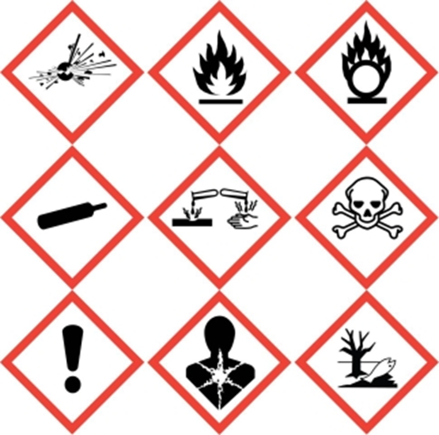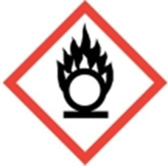 

Aqua Regia is not only a highly corrosive material it is a strong oxidizer as well. Therefore not only will one need to follow the basic precautions of working with corrosive materials as detailed and outlined in the preceding pages but one will need to follow basic guidelines of working with oxidizers as well.

Aqua regia is a mixture of concentrated hydrochloric (3 parts) and nitric (1 part) acids and has the notoriety of dissolving even gold, palladium and platinum. For best results mix the nitric acid into the hydrochloric acid mixture. Because Aqua Regia is a very powerful oxidizer, never let Aqua Regia come into contact with organic materials. See past Aqua Regia incident here: <https://hse.kaust.edu.sa/docs/default-source/research-safety/lfp-safety-bulletins/waste_bottle_explosion.pdf?sfvrsn=e8914db4_2>

HNO3 (*aq*) + 3HCl (*aq*) → NOCl (*g*) + 2H2O (*l*) + Cl2 (*g*)

Over time generated nitrosyl chloride (NOCl) further decomposes producing chlorine gas and nitric oxide (NO) which auto-oxidizes to nitrogen dioxide (NO2), a poisonous reddish-brown gas.

2NOCl (*g*) → 2NO (*g*) + Cl2 (*g*)

2NO (*g*) + O2 (*g*) → 2NO2(*g*)

Be aware that fresh mixtures of aqua regia evolve oxidizing and toxic gases (chlorine, nitric oxide, nitrogen dioxide), therefore making aqua regia should only be done under good exhaust ventilation (i.e. chemical fume hood). Additionally this evolved gas can cause explosions if containers of aqua regia are capped. Therefore containers should be loosley capped. Ideally Aqua Regia solutions should be made fresh (for best results), then used and destroyed/quenched/neutralized shortly after use. Batches should also be created in the smallest size needed; avoid making large batches. If quenching or neutralizing Aqua Regia, pour it into a large volume of ice and then start the neutralization process with an appropriate base such as sodium or potassium hydroxide.

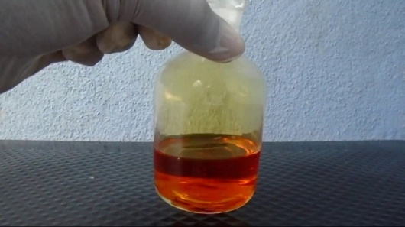

**Key take away points for Aqua Regia (in addition to the already stated for Corrosive Materials)**

* Never clean up spills of Aqua Regia with spill pads or paper towels. Neutralize it first.
* Never store mixtures of Aqua Regia, it can build up pressure! Make it fresh and in small batches for immediate usage. Once done using, neutralize/quench it.
* Never submit Aqua Regia for disposal as closing the container can cause pressure issues from the evolved gases.
* Never mix Aqua Regia with organic materials.
* Be aware of the oxidizing and toxic gases (chlorine, nitric oxide, nitrogen dioxide) evolved from Aqua Regia.

**Training and Documentation**

Training conducted by (print name):____________________________________________

Trainers signature and date:__________________________________________________

Training venue and method. Check all that apply: Classroom/lab lecture

One-on-one Demonstration Hands on Experience SOP review

|  |  |  |
| --- | --- | --- |
| **Date** | **Name** | **Signature** |
|  |  |  |
|  |  |  |
|  |  |  |
|  |  |  |
|  |  |  |
|  |  |  |
|  |  |  |
|  |  |  |
|  |  |  |
|  |  |  |