Guidelines for Working with Corrosive Chemicals – Tetramethylammonium hydroxide

This document is an addendum to *Guidelines For Working With Corrosive Chemicals* (C-1) and is offered to provide a short and concise overview of a widely used and unique hazardous corrosive material. Understanding of the parent document is a crucial perquisite in understanding basic safety fundamentals such as 1) hazard awareness, 2) engineering controls, 3) work practices, 4) PPE and 5) emergency response for working with corrosive materials.

**Tetramethylammonium hydroxide (TMAH)**

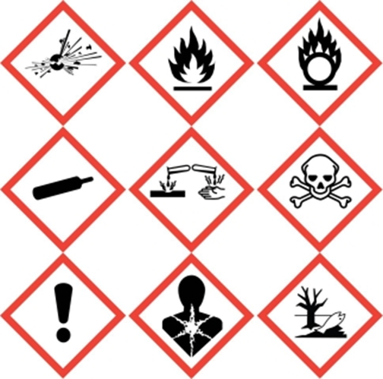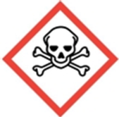 

Tetramethylammonium hydroxide (TMAH) is not only a highly corrosive material it is highly toxic as well. Therefore not only will one need to follow the basic precautions of working with corrosive materials as detailed and outlined in the preceding pages but one will need to follow basic guidelines of working with toxic materials (Particularly Hazardous Substances) as well.

TMAH is a basic corrosive that finds specialized usage for anisotropic etching of silicon (see image below) and in the photolithography field in general such as for stripping of photoresists. This special utility explains why it is popular and widely used. It does however have quite a serious toxicity profile. TMAH’s LD50 (dermal-rat) is between 12.5-50 mg/kg which puts it in the arena of highly toxic. Therefore is critical that PPE usage be adhered to as well as usage under good exhaust ventilation. Due to its high toxicity profile any spill must be cleaned up immediately to prevent exposures and possible harm.

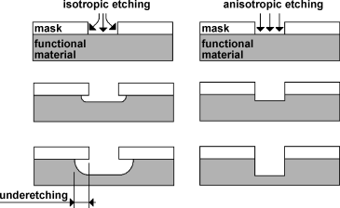

**Key take away points for tetramethylammonium hydroxide (in addition to the already stated for Corrosive Materials)**

* Never clean up spills of TMAH with spill pads or paper towels. Neutralize it first with an organic acid such as citric, malic, or tartaric acid.
* If TMAH is present in a space, all personnel should then be familiar with the First Aid procedures for a possible exposure.
* Store TMAH away from acids and oxidizing materials (TMAH is organic).
* TMAH is highly toxic. Treat it similarly as other particularly hazardous substances (PHS) – use under exhaust ventilation and PPE use is critical! The best gloves for TMAH work are PVC gloves.

**Training and Documentation**

Training conducted by (print name):____________________________________________

Trainers signature and date:__________________________________________________

Training venue and method. Check all that apply: Classroom/lab lecture

One-on-one Demonstration Hands on Experience SOP review

|  |  |  |
| --- | --- | --- |
| **Date** | **Name** | **Signature** |
|  |  |  |
|  |  |  |
|  |  |  |
|  |  |  |
|  |  |  |
|  |  |  |
|  |  |  |
|  |  |  |
|  |  |  |
|  |  |  |
|  |  |  |