Guidelines for Working with Corrosive Chemicals – Piranha

This document is an addendum to *Guidelines For Working With Corrosive Chemicals* (C-1) and is offered to provide a short and concise overview of a widely used and unique hazardous corrosive material. Understanding of the parent document is a crucial perquisite in understanding basic safety fundamentals such as 1) hazard awareness, 2) engineering controls, 3) work practices, 4) PPE and 5) emergency response for working with corrosive materials.

**Piranha solution**

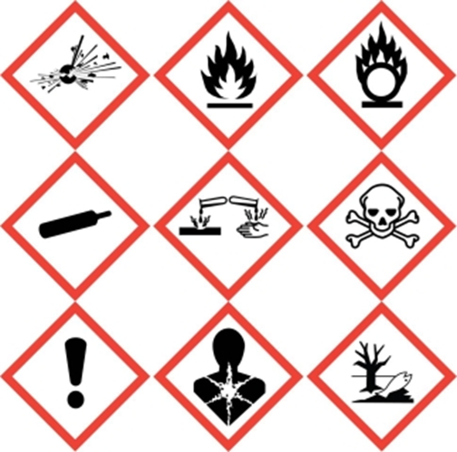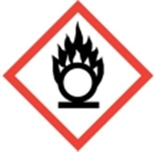 

Piranha solution is not only a highly corrosive material it is a strong oxidizer as well. Therefore not only will one need to follow the basic precautions of working with corrosive materials as detailed and outlined in the preceding pages but one will need to follow basic guidelines of working with oxidizers as well.

Piranha solutions are a mixture of concentrated sulfuric acid and concentrated hydrogen peroxide usually in the ratio of 3:1 to 7:1. It is mostly used to remove trace (not large) amounts of organic material by oxidizing it. For best results, the hydrogen peroxide should be added slowly to the sulfuric acid, not vice versa as the hydrogen peroxide is oxidizing the sulfuric acid into an intermediate called peroxymonosulfuric acid (Caro’s acid). Reversing this order can lead to diminished results.



<https://www.youtube.com/watch?v=CTVd_WxblGI>

Since peroxymonosulfuric acid is a hydroperoxide it can be very unstable/explosive dependent upon conditions. This mixing of these two reagents is a highly exothermic reaction with significant gas evolution, therefore piranha solutions should **never** be tightly capped. Keep caps on loosely! Furthermore if piranha solutions are being created using hydrogen peroxide of 50% or greater, vessel cooling may be required to prevent possible explosions. Peroxides and heat do not mix! The larger the batch of piranha that is being created, the more heat will be generated. Keep batches as small as possible.

Piranha solutions should only be disposed as hazardous waste after confirming that the mixture is no longer generating gas (usually 1-2 weeks). Clearly label all piranha solutions including waste. Due to the problematic hazards of piranha solutions see if alternatives are feasible such as NoChromix, Nanostrip, or possibly even KOH/ethanol baths.

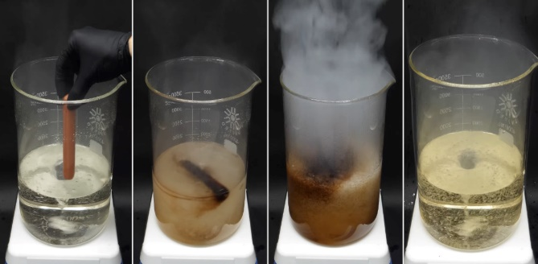

**Key take away points for piranha solution (in addition to the already stated for Corrosive Materials)**

* Never clean up spills of piranha with spill pads or paper towels. Neutralize piranha solution first.
* Store piranha away from organic materials.
* Clearly label all piranha solution containers including waste containers.
* Never store piranha solution with a tight fitting cap. Keep the cap closed loosely until you have ensured that the solution has stopped evolving gas (can take weeks). Once stable (no gas evolution), then cap can be closed tightly and submitted for disposal.
* For best results, add hydrogen peroxide to the sulfuric acid, not vice versa. This mixing will be very exothermic! If using hydrogen peroxide of 50% strength or more, cooling may very well be necessary to prevent explosions.

**Training and Documentation**

Training conducted by (print name):____________________________________________

Trainers signature and date:__________________________________________________

Training venue and method. Check all that apply: Classroom/lab lecture

One-on-one Demonstration Hands on Experience SOP review

|  |  |  |
| --- | --- | --- |
| **Date** | **Name** | **Signature** |
|  |  |  |
|  |  |  |
|  |  |  |
|  |  |  |
|  |  |  |
|  |  |  |
|  |  |  |
|  |  |  |
|  |  |  |