Guidelines for Working with Corrosive Chemicals – Perchloric acid

This document is an addendum to *Guidelines For Working With Corrosive Chemicals* (C-1) and is offered to provide a short and concise overview of a widely used and unique hazardous corrosive material. Understanding of the parent document is a crucial perquisite in understanding basic safety fundamentals such as 1) hazard awareness, 2) engineering controls, 3) work practices, 4) PPE and 5) emergency response for working with corrosive materials.

**Perchloric acid**

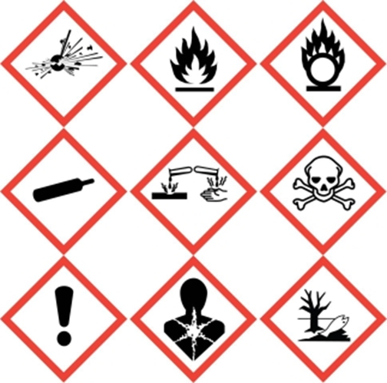

Perchloric acid is not only a highly corrosive material it is a strong oxidizer as well. Therefore not only will one need to follow the basic precautions of working with corrosive materials as detailed and outlined in the preceding pages but one will need to follow basic guidelines of working with oxidizers as well. However, perchloric acid only acts as an oxidizing agent when heated or in the anhydrous state (>85%), which then it can be explosive when in contact with organic matter.

Perchloric acid does readily react with metals to form potentially explosive metal perchlorate salts. This is why if perchloric acid is to be used on a regular basis in fume hoods, these fume hoods need to be specially designed and have a wash down feature. Perchloric acid fume hoods are specially designed with this wash down feature as well as other features such as a collection basin and non-reactive furniture (e.g. plastic, ceramic, etc) to reduce metal-perchloric acid interaction. Perchloric acid fume hoods are rare and mostly found in institutions where Geology type work is done – Perchloric acid is heated and used for rock and mineral digestions.

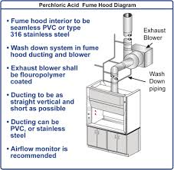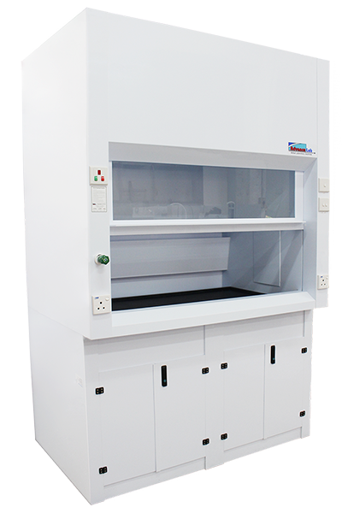

**Key take away points for perchloric acid (in addition to the already stated for Corrosive Materials)**

* Never clean up spills of perchloric acid with spill pads or paper towels. Neutralize perchloric acid first.
* Store perchloric acid away from metals and organic materials (organic acids). Use secondary containers if you must store perchloric acid with organic acids.
* Be extremely cognizant of the material (organic, metals, etc) and manner (heating, diluted or concentrated) you use perchloric acid with.
* Never heat perchloric acid, unless you have special training, as this helps to dehydrate it and makes it more reactive and potentially explosive.

**Training and Documentation**

Training conducted by (print name):____________________________________________

Trainers signature and date:__________________________________________________

Training venue and method. Check all that apply: Classroom/lab lecture

One-on-one Demonstration Hands on Experience SOP review

|  |  |  |
| --- | --- | --- |
| **Date** | **Name** | **Signature** |
|  |  |  |
|  |  |  |
|  |  |  |
|  |  |  |
|  |  |  |
|  |  |  |
|  |  |  |
|  |  |  |
|  |  |  |
|  |  |  |
|  |  |  |