Guidelines for Working with Corrosive Chemicals – Nitric acid

This document is an addendum to *Guidelines For Working With Corrosive Chemicals* (C-1) and is offered to provide a short and concise overview of a widely used and unique hazardous corrosive material. Understanding of the parent document is a crucial perquisite in understanding basic safety fundamentals such as 1) hazard awareness, 2) engineering controls, 3) work practices, 4) PPE and 5) emergency response for working with corrosive materials.

**Nitric acid**

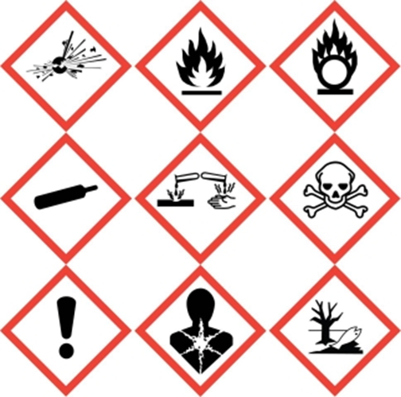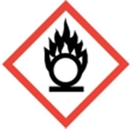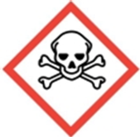

Nitric acid is not only a highly corrosive material it is a strong oxidizer as well. Therefore not only will one need to follow the basic precautions of working with corrosive materials as detailed and outlined in *Guidelines For Working With Corrosive Chemicals* (C-1) but one will need to follow basic guidelines of working with oxidizers as well.

Because of Nitric acid’s ubiquitous use throughout many labs coupled with its oxidizing properties, many times it is accidently mixed with incompatible materials resulting in over pressurized containers, explosions, fires, etc. To drive home this point, one only need to do a simple google search for “*another nitric acid accident*” to see the immense number of incidents that happen due to people accidentally mixing nitric acid with organic materials.

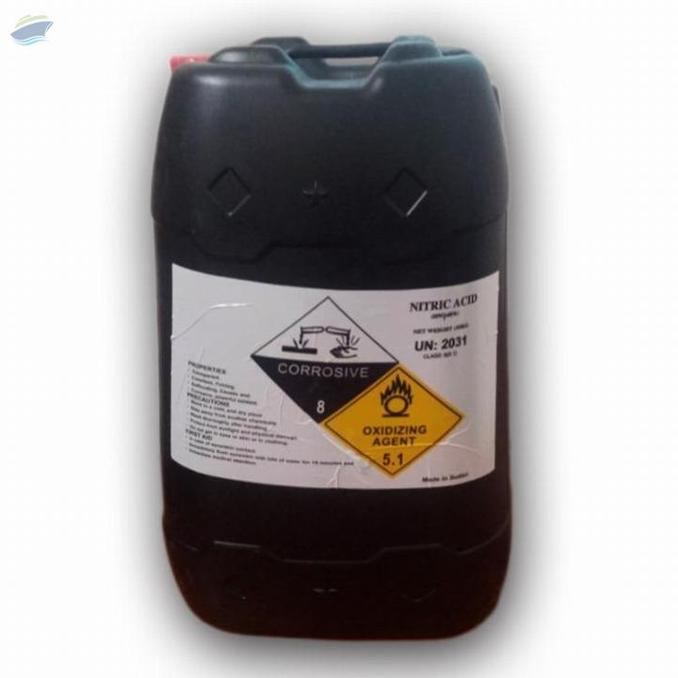

*Therefore it is critical to remember to never mix nitric acid with any organic material including organic acids unless you are purposefully trying to nitrate or oxidize it.* See the attached [video](https://www.youtube.com/watch?v=uFwiZYfEsuY) of nitric acid being added to ethanol to understand the reaction of nitric acid upon organic material. In addition when disposing of nitric acid (regardless of concentration) always be sure to ensure the waste container has no residual organic material in it or vice versa that you are not adding organic materials to nitric acid waste. Also never use spill pads/paper towels to cleanup a spill of nitric acid. Neutralize the nitric acid first.

**Key take away points for nitric acid (in addition to the already stated for Corrosive Materials)**

* Never clean up spills of nitric acid with spill pads or paper towels. Neutralize nitric acid first.
* Store nitric acid away from organic materials (organic acids). Use secondary containers if you must store nitric acid with organic acids.
* Never mix nitric acid with organic materials unless you are purposefully trying to nitrate or oxidize it.
* Be especially careful that nitric acid waste is disposed in a container free of organic residue. Never mix nitric acid waste with organic waste.

**Training and Documentation**

Training conducted by (print name):____________________________________________

Trainers signature and date:__________________________________________________

Training venue and method. Check all that apply: Classroom/lab lecture

One-on-one Demonstration Hands on Experience SOP review

|  |  |  |
| --- | --- | --- |
| **Date** | **Name** | **Signature** |
|  |  |  |
|  |  |  |
|  |  |  |
|  |  |  |
|  |  |  |
|  |  |  |
|  |  |  |
|  |  |  |
|  |  |  |
|  |  |  |
|  |  |  |