Purpose
The purpose of this document is to set out the procedures to be followed when receiving shipments of radioactive materials in the Radiation Labeling Core Laboratory (RLCL), to ensure every radioactive material delivered in good conditions and received accordingly.

Scope
This procedure is applied to all the radioactive materials purchased under the KAUST license including both sealed and unsealed sources.

Definitions
Contamination | The presence of a radioactive substance on a surface in quantities in excess of NRRC limits in Table.1. As a rule of thumb a reading that is two times the background is an indication of contamination.
Exempted Quantities | Small amounts of radioactive material that is exempted from regulatory control and treated as non-radioactive in many countries except Saudi Arabia.
Excepted Package | A package without radiation external labeling that contain a radiation activity such that the whole radioactive content if released would not cause a significant hazard.
Survey meter | Portable radiation detection and measurement instruments used to check personnel, equipment and facilities for radioactive contamination or to measure external or ambient ionizing radiation fields.
Transport Index (TI) | The dimensionless number placed on the label of a package to designate the degree of control to be exercised by the carrier during transportation (Table.2). The TI is equal to the maximum radiation level in mRem/hour (µSv/hr divided by 10) at one meter from an undamaged package.
UN 2910 | Radioactive material, excepted package-limited quantity of material
Wipe test | A procedure used to assess surface contamination when direct measurements using a surface contamination meter are not possible.

Procedures

- Delivery of radioactive material packages from the airport to KAUST should be done by the authorized transportation company contracted by the HSE.
- Receiving of the radioactive material package shall be done by the Radiation Safety Officer or delegated safety specialists.
- The delivery of the packages must use the designated pathway approved by the RSO and the authorized transportation company.
- PPE such as protective gloves, safety glasses, lab coat and radiation badge must be worn before proceeding with packages receipt.
- Move the packages to a designated radioactive work area. If the material is volatile (tritium, radioactive gases, etc.) or in a powder form, open the package in a fume hood.
- Visually inspect the package before opening it for any sign of damage, breakage, leakage or crushing during transport. If damage is noted, stop and notify the RSO.
- Verify that the radioactive material in the package is what was ordered. If the items listed on packing note do not match with ordering, the package shall not be received and the RSO shall be contacted for further instruction.
- All packages that are received with a White I, Yellow II, or Yellow III label shall be monitored for surface contamination and external radiation levels within 3 hours after receipt in the RLCL.
- If the package has no labels because it was shipped as exempted radioactive materials or as excepted package under UN2910 then skip to step 11.
- Monitor the radiation field around the package using an appropriate survey meter by obtaining the dose rate at one meter and compare with the Transport Index or the units stated on the package (Figure 1). Repeat the measurement for the surface of the package and record all reading. Notify the RSO if the dose rates do not match.
- Perform wipe test on the outer surface of the package. Survey the wipe with a survey meter unless you are receiving H-3 or C-14 in which case you must use a liquid scintillation counter. Record all readings. If the wipe test results at surface exceed the NRRC limits in table 2 or above than three times background (for the sake of simplicity), it is recommended to decontaminate and re-monitor.
- Open the outer package and remove the packing slip. Open the inner package and verify that the contents agree in name and quantity with the packing slip.
- Repeat step 11 on the inner contents.
- If material has been packaged in dry ice, refrigerate.
- If contamination results are greater than 6 times background, then it shall be reported to the RSO.
- If contamination, leakage or shortages are observed, notify the vendor’s Customer Service department immediately by email or telephone and request instructions.
- Log the radioisotope, activity, date received in the inventory record (Appendix 1).
- If the package and liner are free of contamination, remove or deface all radiation warning symbols or text before discarding into regular trash.

Table 1. Activity Level Limits
NRRC Radioactive Contamination Limits for Packages | Radionuclides | Maximum Permissible Limits*
 | C-14, P-32, P-33 H-3 | 40 Bq/cm² | 1 x 10⁻³ µCi/cm² | 2400 dpm/cm²
 | Na-22,Cl-36 | 4 Bq/cm² | 1 x 10⁻⁴ µCi/cm² | 240 dpm/cm²

Table2. Transport Index
(TI) | Label | Category of Label | Maximum  Contact Dose Rate | Maximum Dose Rate at 1 Meter
0 | 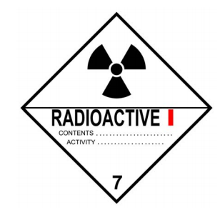 | White-I | 5 µSv/hr | N/A
0-1 | 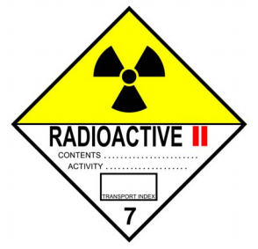 | Yellow-II | 500 µSv/hr | 10 µSv/hr
1-10 | 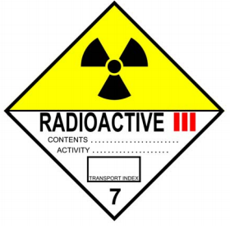 | Yellow-III | 2000 µSv/hr | 100 µSv/hr

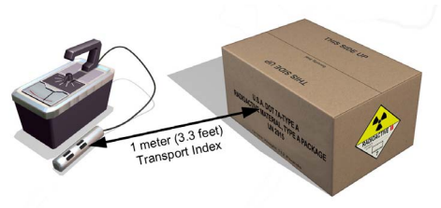
Fig.1 Verification of Transport Index

Document History
Rev | Date | Prepared By | Description
01 | Aug 2019 | M. Bahmaid | New document
02 | Nov 2019 | M. Bahmaid | Revised document V.2
03 | April 2024 | M. Bahmaid | Revised according to PolicyTech format v.3

Appendix 1- Package reception record

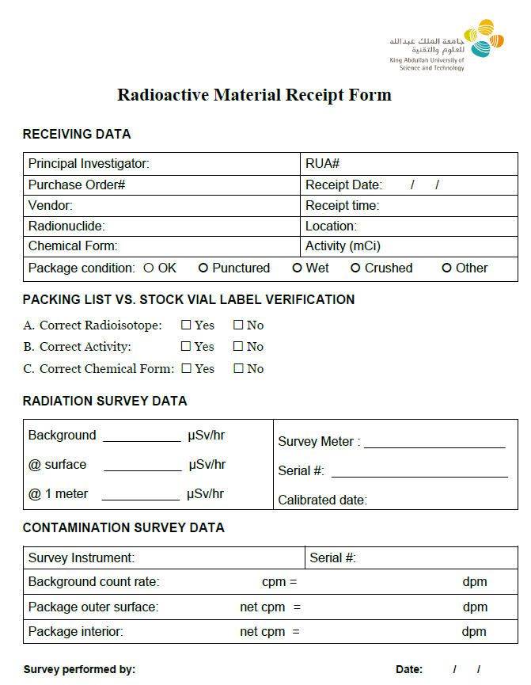

Appendix 2

Converting Counts per Minute (CPM) to DPM or Bq/cm²

- Calculating contamination level in DPM:

DPM = CPM X 100/Efficiency (%)

- Calculating contamination level in Bq/cm² for LSC:

Bq/cm² = (CPM – Bkg) / (Ec X Ew X 60 X A)

Where:
- CPM = counts per minute for the wipe
- Bkg = counts per minute of the background
- Ec = scintillation counter efficiency
- Ew = wipe efficiency, assume 10% (0.1) and
- A = area wiped in cm²

- Calculating contamination level in Bq/cm² for Survey Meters:

Bq/cm² = (CPM – Bkg) / (Ec X Ew X 60 X A)

Where,
- CPM = counts per minute for the wipe
- Bkg = counts per minute of the background
- Ec = GM efficiency
- Ew = wipe efficiency, assume 10% (0.1) and
- A = area wiped in cm² (19.6 cm² for a pancake probe)

