**BUILDING EVACUATION PLAN BUILDING 4**

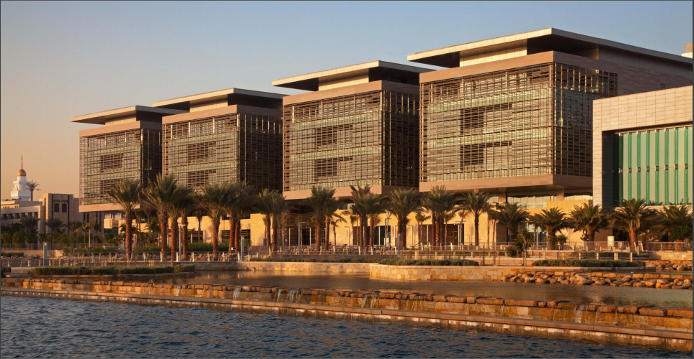

|  |
| --- |
| **Responsible Person** |
| To be advised by senior Building 4 managers. |
| **BUILDING LIAISON TEAM**  **KAUST Fire Services: Nicholas Cheatle**  **FM Building Management: Youmna Daw**  **Research Safety Team: Mohammad A. Bahmaid**  **Core Lab/RST: Mohammad Zahid Iqbal**  **Lead Fire warden: Ralph Timmermeester** |
| Date last updated: **09/06/2024** |

**Introduction**

The purpose of this Emergency Evacuation Plan is to provide for the safe and efficient evacuation of the building in the event of an Emergency Evacuation. This plan is an essential part of the KAUST Building Emergency Evacuation Program, which covers the following areas:

* Identifying all who are affected by an Emergency Evacuation
* Identifying roles and responsibilities of personnel before, during, and after an Emergency Evacuation.

**Persons who are affected by an Emergency Evacuation**

**All** occupants of the building at the time of an Emergency Evacuation are affected, including:

* Persons working/studying in the building.
* Persons visiting the building for any reason whatsoever.

**Roles and Responsibilities**

This section identifies the roles and responsibilities of any person/department that is involved in the provision and execution of the Building Emergency Evacuation Plan.

* KAUST Fire Department
* KAUST Security
* Supervisors/Managers/Building Managers/etc.
* All occupants of a building
* Fire Wardens

**KAUST Fire Department will:**

* Help you to provide, maintain and periodically test the Emergency Evacuation Plans of the Campus Buildings.
* Other than Campus Buildings, provide advice on the provision and periodically test the Emergency Evacuation Plans for all other buildings in KAUST.
* Assist with the planning and execution of Building evacuation drills as per international standards and codes.
* Provide all necessary Fire Safety/Warden Training and give any required advice/assistance.
* Provide (Orange) Fire Warden Jackets for all areas, which should be used in the event of an Emergency Evacuation.
* Respond to all Emergency Evacuations, deal with the cause of the evacuation and ensure that the building is safe to be re-occupied as efficiently as possible.
* Endeavor wherever possible to keep all concerned informed of the progress of the incident and/or when it is safe to re-enter the building.

**KAUST Security will:**

* On arrival at the scene of an Emergency Evacuation, secure the main entrance to the building and ensure that nobody enters/re-enters without the Fire Officer in Command giving permission.
* Where possible, ensure that the approach to the scene is kept clear for the responding Emergency Services.
* Provide to the Fire Officer in Command extra personnel, if available, when requested in order to secure the rest of the building/incident.
* If requested to do so by the Fire Officer in Command, inform all concerned that it is safe to re-enter the building or keep them informed as to the progress of the incident.

**Responsible Person**

* Will delegate duties as they see fit to LSRs/Supervisors/Managers/Building Managers/etc.
* Ensure that all personnel/visitors in their area of responsibility are aware of what they must do in the event of an Emergency Evacuation.
* Nominate/identify sufficient persons/volunteers, in their area of responsibility, to perform the roles of Fire Wardens. There should be sufficient numbers to cover for any type of absence, whether of a long or short duration. (See BEMP for advice)
* Ensure that the Building Evacuation Plan, is updated whenever there is a change to details including Responsible Person, Fire Wardens, Emergency contact details, PEEPs, etc. This can be done by emailing [BEP@KAUST.EDU.SA](mailto:BEP@KAUST.EDU.SA) as changes in personnel occur.
* Ensure that each Fire Warden knows the extent of the area that they are responsible for.
* Organize Emergency Evacuation Drills at least two times annually (please see the Building Evacuation Management Procedure (BEMP)for exact code requirements as per IFC/IBC for your specific Building / occupancy type), which should be recorded along with all actual Emergency Evacuations.

**All occupants of the building**

On hearing the alarm, all occupants will:

* Stop work and immediately begin to evacuate the building using the nearest exit and proceed to your designated Assembly Area.
* Providing it is safe to do so, make any areas or processes safe which have been agreed as part of the building or area Evacuation Plan.
* Never assume a false alarm. Continue to evacuate **even if the alarm stops sounding**.
* Use the nearest escape exit or stairs - **DO NOT** use the elevators.
* Keep doors in stairways closed and close all doors behind you unless there are persons directly behind you evacuating.
* Proceed in an orderly manner until you reach your designated Assembly Area.
* Assist anyone who appears to be having difficulty evacuating, but **DO NOT** place yourself at risk.
* If you are assisting a person who is mobility impaired and has difficulty descending the stairs, assist them to the nearest Safe Refuge Point, e.g. a protected staircase landing and immediately on exiting the building inform a member of the emergency services of their location.
* If you cannot assist someone who requires assistance, report their location to the nearest Fire Warden, Security Officer, Fire Officer or call 911 (**012 808 0911** *if calling on mobile*) and inform them of the situation.
* Remain in the Assembly Area and do not re-enter the building, **even if the alarm has stopped sounding,** until the "All Clear" is announced by the Fire Department or Security Personnel.
* If you have any relevant information regarding the incident or information which you feel is important to the emergency responders, pass the information to the nearest Security Officer, Fire Officer or call 911 (**012 808 0911** *if calling on mobile*) and pass the information on to them for onward dispatch to the Fire Department Incident Commander.
* If the incident is likely to be protracted information will be provided to the building occupants which may include informing the occupants to return to the assembly point at a later time or leave the area altogether depending on the nature and severity of the incident. Information may be provided by the Fire Department or the Security Department.

On discovering a Fire, they should, without putting themselves in danger and only if possible:

* Isolate any power, gas, fuel, etc.
* Close the door, once all occupants have evacuated the room, to stop the spread of the fire.

If the Fire Alarm has not been automatically activated, raise the alarm by activating the nearest “Manual Pull Station” and evacuate the building.

**Note:** The Building Evacuation Alarm can be activated by any, all, or a combination of the following means:

* Manually, by the operation of a Manual Pull Station. Automatically, by activation of a Smoke Detector, Heat Detector, or Toxic Gas Monitoring (TGM) Alarm.



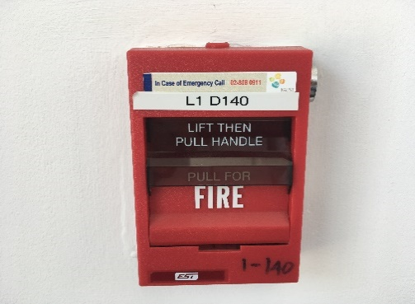 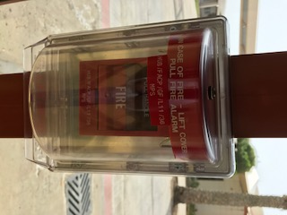

* Call for assistance and attack the fire with the extinguishing equipment provided, but only if you are trained and confident to do so. If you are not trained to use a Fire Extinguisher you should close the door to the room where the fire is, once all occupants have evacuated the room, leave the building immediately and proceed to the nearest Assembly Area. **(See Appendix 1 for maps of Assembly Areas and Emergency Exits.)**

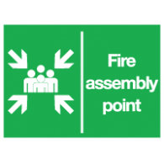

* **DO NOT** put yourself or others in danger!

**Fire Wardens will:**

Before assuming the role of Fire Warden

* Ensure that they are trained, equipped, and fully understand what is required of them as a Fire Warden and It is recommended that Fire Wardens request refresher training every two years.
* Ensure that they are fully aware of the area in which they work, including Escape Routes, locations and types of Fire Extinguishers, Assembly Points, Emergency Pull Stations, how and when to contact the Emergency Services, their exact location, (e.g., Building, Floor, Area, Lab), etc.
* Identify any person in their area of responsibility who may need assistance in the event of an Emergency Evacuation and, using a Personal Emergency Evacuation Plan (PEEP) make arrangements to assist that person. (Examples are attached to this Building Evacuation Plan)

**Note:** Issues that each Fire Warden should be constantly aware of in their areas

**Fire Exits:**

* Are the exits clear of all obstructions, both inside and outside?
* Are the Emergency Exit doors in proper working order?

**Escape Routes:**

* Are all Escape Routes clear of obstructions?
* Are escape routes clearly marked?

**Fire Doors:**

* Are all Fire Doors closed and in good working order?

**Signage:**

* Is the emergency signage sufficient for the risks in your area?
* Is the emergency lighting sufficient for the area and in working order?

**Fire Detection System:**

* Do all components of the Fire Alarm System in your area appear to be in good order with no sign of obvious damage or obstruction?

**Sprinkler System:**

* Do all components of the Sprinkler System in your area appear to be in good order with no sign of obvious damage or obstruction?

**Fire Extinguishers:**

* Do any Fire Extinguishers need to be replaced for any reason?
* Are there any missing Fire Extinguishers from their positions?
* Are the Fire Extinguishers clearly visible to anyone who needs to use them?
* Are the Fire Extinguishers appropriate for the types of hazard present?

**Evacuation Equipment:**

* Is all of the evacuation equipment required during an Emergency Evacuation present and in good working order? (e.g. Evacuation Chairs)

**Storage:**

* Is any equipment/stock stored in such a way as to cause a Fire Risk or to impede an Emergency Evacuation, or to increase the danger during a fire? (e.g. Gas Cylinders, Wooden Packaging, Chemicals)
* Are there any items being stored that could potentially be dangerous if they were to interact with each other in the event of an incident?
* Are there any items being stored in such volumes or of a dangerous nature that in the event of an incident they could be dangerous to Fire fighters or increase the danger of fire?

On hearing the alarm Fire Wardens should:

* Put on their **Orange** Fire Warden vest and then instruct/assist occupants to evacuate the building through the nearest Emergency Exit and proceed to the nearest Assembly Area.

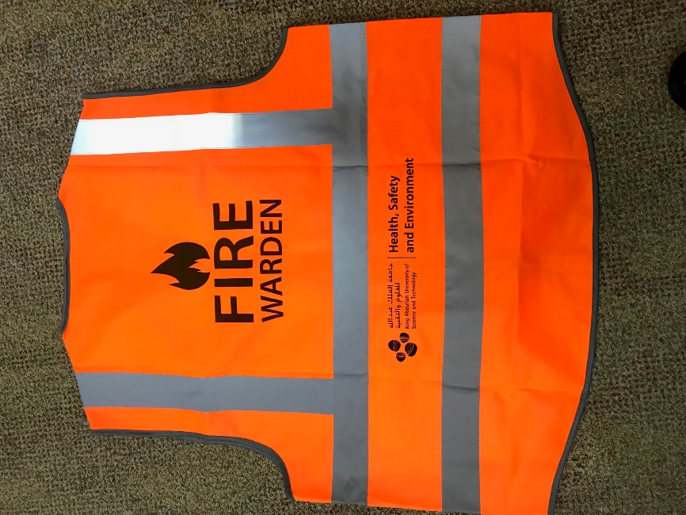

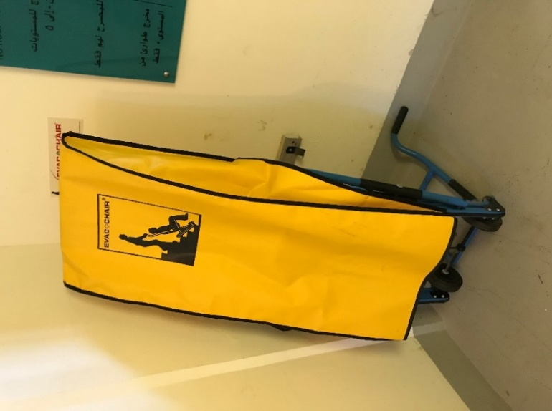

* Assist, when designated to do so, a person with a Personal Emergency Evacuation Plan (PEEP). This may involve the use of an Evac Chair.
* **DO NOT USE THE ELEVATORS**
* Without putting themselves in danger, they should carry out a “Quick Sweep” of their area of responsibility to ensure that all occupants have evacuated.
* If possible ensure any heat generating equipment is isolated.
* They should ensure that all doors are closed (**not locked**) on the way out of the building.
* On exiting the building, if they see that there is no Fire Warden or Security present, they should take up position at the door to ensure that the emergency services have access to the building to deal with the emergency.
* On exiting the building the Fire Warden should, if possible, confirm that someone has called 911 (**012 8080911** *if calling on mobile*). The Fire Alarms are constantly monitored by 911 Control but a phone call confirmation from the scene is an essential backup and may provide extra useful information.
* On reaching the designated Assembly Point, stay there with the rest of the occupants until the Fire Department declares that it is safe to return to the building.
* When possible, a Fire Warden from the area in which the alarm activated should make themselves available to the emergency services to provide any local or technical knowledge they may have to offer.

On discovering a small fire a Fire Warden should only attempt to tackle the fire with an appropriate Fire Extinguisher if:

* They are trained to use that extinguisher.
* They do NOT put themselves in any danger whatsoever.
* They are fully confident that they can extinguish the fire.
* They are not alone.
* The alarm has been raised to alert other building occupants and the Fire Department.

If they discover a fire that they are **not** going to attempt to extinguish they should, without putting themselves in danger and only if possible:

* Isolate any power, gas, fuel, etc.
* Close the door to stop the spread of the fire unless, of course, there are persons directly behind you evacuating.
* Raise the alarm by activating the nearest “Manual Pull Station” and assist in the Emergency Evacuation of the building.

**Special Requirements**

Should it be identified that in the event of an Emergency Evacuation any occupants will require special assistance or equipment, the details of the requirements and provisions should be clearly outlined in the form of a Personal Emergency Evacuation Plan (PEEP).

**PERSONAL EMERGENCY EVACUATION PLAN (PEEP)**

A Personal Emergency Evacuation Plan (PEEP) is a tailored escape plan for individuals who may not be able to reach an ultimate place of safety unaided or within a satisfactory period of time in the event of any emergency**.**

**Who needs a PEEP?**

A PEEP may be required for staff with:

* Mobility impairments
* Sight impairments
* Hearing impairments
* Cognitive impairments
* Other circumstances

A temporary PEEP may be required for:

* Short term injuries (i.e. broken leg)
* Temporary medical conditions
* Those in the later stages of pregnancy

The underlying question in deciding whether a PEEP is necessary is "can the person evacuate the building unaided and in a prompt manner during an emergency situation?" If the answer is "no", then it is likely that a PEEP is required. If an individual feels that a PEEP is necessary for them they should contact their Fire Warden and ask that a PEEP be put in place.

On the following pages there are examples of both a blank PEEP and a completed PEEP.

**Example of a blank PEEP**

|  |  |  |  |  |  |  |  |  |  |  |  |  |
| --- | --- | --- | --- | --- | --- | --- | --- | --- | --- | --- | --- | --- |
| **PERSONAL EMERGENCY EVACUATION PLAN** | | | | | | | | | | | | |
|  | | | | | | | | | | | | |
| **Name** | | | |  | | | | | | | | |
| **Department** | | | |  | | | | | | | | |
| **Building Floor and Area** | | | |  | | | | | | | | |
| **Phone Number** | | | |  | | | | | | | | |
| **AWARENESS OF PROCEDURE** | | | | | | | | | | | | |
| **______________________** is informed of an Emergency Evacuation by: (please tick X relevant box) | | | | | | | | | | | | |
|  | | | |  |  | | | | | | | |
| Fire Alarm system: | | |  | | |  | Visual Alarm System: | | | |  |  |
|  | | |  | | |  |  | | | |  |  |
| Fire Warden: | | |  | | |  | Other (please specify): | |  | | | |
|  | | |  | | |  |  | |  | | |  |
| **DESIGNATED ASSISTANCE** | | | | | | | | | | | | |
| The following have been designated to give _________ assistance to get out of the building in an emergency. | | | | | | | | | | | | |
| **Name** | | | |  | | | | | | | | |
| **Contact Details (Floor, Area & Phone)** | | | |  | | | | | | | | |
| **Name** | | | |  | | | | | | | | |
| **Contact Details (Floor, Area & Phone)** | | | |  | | | | | | | | |
| **METHODS OF ASSISTANCE (e.g. Transfer procedures, methods of guidance etc)** | | | | | | | | | | | | |
|  | | | | | | | | | | | | |
| **EQUIPMENT PROVIDED (including means of communication)** | | | | | | | | | | | | |
|  | | | | | | | | | | | | |
| **PERSONALISED EVACUATION PROCEDURE (A step by step account beginning with the first alarm)** | | | | | | | | | | | | |
| 1 |  | | | | | | | | | | | |
| 2 |  | | | | | | | | | | | |
| 3 |  | | | | | | | | | | | |
| 4 |  | | | | | | | | | | | |
| **MONITOR AND REVIEW** | | | | | | | | | | | | |
|  | | | | | | | | | | | | |
| **Signed by Manager** | |  | | | | | | Date | |  | | |
| **Signed by Individual** | |  | | | | | | Date | |  | | |

**Example of a completed PEEP**

|  |  |  |  |  |  |  |  |  |  |  |  |  |
| --- | --- | --- | --- | --- | --- | --- | --- | --- | --- | --- | --- | --- |
| **PERSONAL EMERGENCY EVACUATION PLAN** | | | | | | | | | | | | |
|  | | | | | | | | | | | | |
| **Name** | | | | **Seamus Murphy** | | | | | | | | |
| **Department** | | | | **Engineering** | | | | | | | | |
| **Building Floor and Area** | | | | **Floor 2 Area 4** | | | | | | | | |
| **Phone Number** | | | | **12345678** | | | | | | | | |
| **AWARENESS OF PROCEDURE** | | | | | | | | | | | | |
| **Seamus Murphy** is informed of an Emergency Evacuation by: (please tick X relevant box) | | | | | | | | | | | | |
|  | | | |  |  | | | | | | | |
| Fire Alarm system: | | | X | | |  | Visual Alarm System: | | | |  |  |
|  | | |  | | |  |  | | | |  |  |
| Fire Warden: | | |  | | |  | Other (please specify): | |  | | | |
|  | | |  | | |  |  | |  | | |  |
| **DESIGNATED ASSISTANCE** | | | | | | | | | | | | |
| The following have been designated to give (**Seamus Murphy**) assistance to get out of the building in an emergency. | | | | | | | | | | | | |
| **Name** | | | | **James Rogers** | | | | | | | | |
| **Contact Details (Floor, Area & Phone)** | | | | **Floor 2 Area 4 01234567** | | | | | | | | |
| **Name** | | | | **Melanie Smith** | | | | | | | | |
| **Contact Details (Floor, Area & Phone)** | | | | **Floor 2 Area 4 02345678** | | | | | | | | |
| **METHODS OF ASSISTANCE (e.g. Transfer procedures, methods of guidance etc)** | | | | | | | | | | | | |
| **Seamus can walk to the stairwell where he will require 2 persons and the EVAC Chair to go down the stairs.** | | | | | | | | | | | | |
| **EQUIPMENT PROVIDED (including means of communication)** | | | | | | | | | | | | |
| **EVAC Chair which is located on the wall in stairwell “A”. Communications will be by mobile phone to other Fire Wardens as required.** | | | | | | | | | | | | |
| **PERSONALISED EVACUATION PROCEDURE (A step by step account beginning with the first alarm)** | | | | | | | | | | | | |
| 1 | **On activation of the alarm Seamus will make his way to stairwell “A”.** | | | | | | | | | | | |
| 2 | **James and Melanie will meet Seamus in the stairwell and, when the stairwell is clear of other evacuees, assist him down the stairs using the EVAC Chair. James or Melanie will first inform another Fire Warden by mobile that they are proceeding down the stairs.** | | | | | | | | | | | |
| 3 | **The Fire Warden downstairs will inform the Fire Department about Seamus and they may offer assistance.** | | | | | | | | | | | |
| 4 |  | | | | | | | | | | | |
| **MONITOR AND REVIEW** | | | | | | | | | | | | |
| **This plan will be reviewed annually.** | | | | | | | | | | | | |
| **Signed by Manager** | |  | | | | | | Date | |  | | |
| **Signed by Individual** | |  | | | | | | Date | |  | | |

*To be completed by the Manager.*

**Specific risks or concerns and mitigation measures (if any).**

In the case where there are special risks or concerns associated with an Emergency Evacuation they should be identified here along with any mitigating measures put in place to address them.

|  |  |  |  |  |
| --- | --- | --- | --- | --- |
| **Type of Risk** | **Location** | **Mitigation Measures**  **(If any)** | **Responsible Person** | **Contact Details** |
|  |  |  |  |  |
|  |  |  |  |  |
|  |  |  |  |  |
|  |  |  |  |  |
|  |  |  |  |  |
|  |  |  |  |  |
|  |  |  |  |  |
|  |  |  |  |  |
|  |  |  |  |  |
|  |  |  |  |  |
|  |  |  |  |  |

**Emergency contact numbers related to this building should be entered in the chart below.**

|  |  |  |  |
| --- | --- | --- | --- |
| **Department** | **Name** | **Phone Number** | **Email Address** |
|  |  |  |  |
|  |  |  |  |
|  |  |  |  |
|  |  |  |  |
|  |  |  |  |
|  |  |  |  |
|  |  |  |  |
|  |  |  |  |
|  |  |  |  |
|  |  |  |  |
|  |  |  |  |
|  |  |  |  |
|  |  |  |  |
|  |  |  |  |
|  |  |  |  |

**Record of Emergency Evacuations (Real or Practice)**

“Date” and “Location” should be recorded by the department involved.

“Cause” should be recorded by whichever department is responsible for

investigating and rectifying the cause

|  |  |  |
| --- | --- | --- |
| **Date** | **Location** | **Cause** |
| 06/06/2024 | FACP drill mode Level 0 | Announced building evacuation drill. |
|  |  |  |
|  |  |  |
|  |  |  |
|  |  |  |
|  |  |  |
|  |  |  |
|  |  |  |
|  |  |  |
|  |  |  |
|  |  |  |
|  |  |  |
|  |  |  |
|  |  |  |
|  |  |  |

**Active Fire Warden List for Building 4**

|  |  |  |  |  |
| --- | --- | --- | --- | --- |
| **Building Fire Wardens Building 4** | | | | |
| **Offices** | **Level** | **Area** | **Primary Fire Warden** | **Secondary Fire Warden** |
| Central Fabrication Lab | 0 | 4 | David Llewellyn | Tayyab Mubeen |
| Electronics Fabrication Lab | 0 | 1 | Meshal Abdulkareem | Michael A. Bayudan |
| Reverse Engineering Lab | 0 | 1 | Nikolas Papagiannis | Muhammad Kashif |
| Scientific Glassblowing Lab | 0 | 1 | Ernest Davidson | Lukasz Malcyzk |
| Lab Equipment Maintenance | 0 | 1 | Ralph Timmermeester | Edgardo Mateo  Balamurugan Ramasamy |
| 4-2610 | 2 | 1 | Seraj Muhammad | Caroline Chaix |
| 4-3610 | 3 | 1 | Hiba Elgezouli |  |
| 4-3830 | 3 | 4 | Nilamani Sahoo | Truman Spencer |
| 4-4650 | 4 | 1 | Ali Alansari | Rawan Rajhi |
|  |  |  |  |  |
|  |  |  |  |  |
|  |  |  |  |  |
|  |  |  |  |  |
|  |  |  |  |  |
|  |  |  |  |  |
|  |  |  |  |  |
|  |  |  |  |  |
|  |  |  |  |  |
|  |  |  |  |  |
|  |  |  |  |  |
|  |  |  |  |  |
|  |  |  |  |  |

**Fire Warden Training**

Fire Warden training is provided by the Fire Department at the Fire Station. Places on the courses can be reserved by accessing the web address below. Click on the desired course on the calendar and complete the registration form. The training courses are usually held on Monday / Wednesday mornings starting at 8.30 am and lasting approximately 3 hours.

LINK:

<https://hse.kaust.edu.sa/training/fire-safety-training>

A further guide to Fire Wardens can be found in the BEMP Building Evacuation Management Procedure.

**Appendix 1**

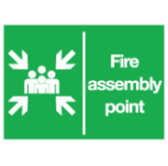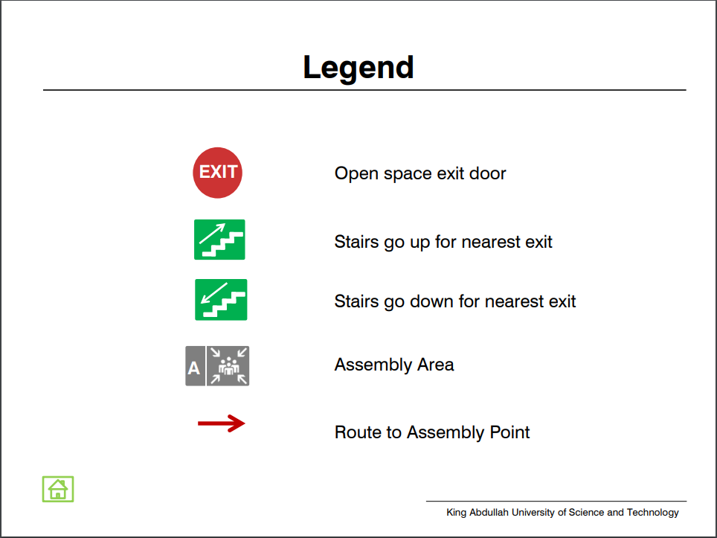

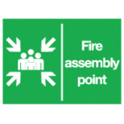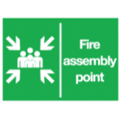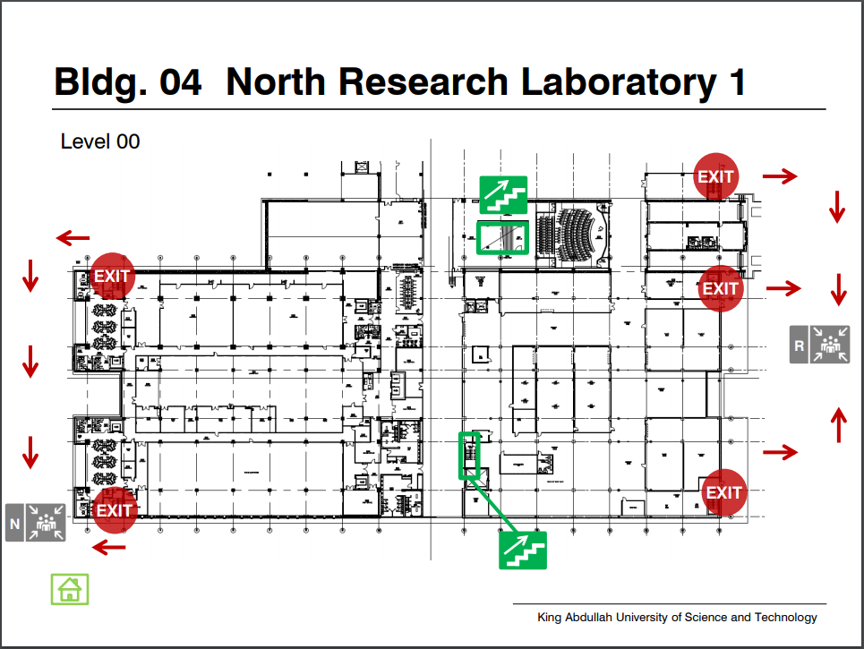

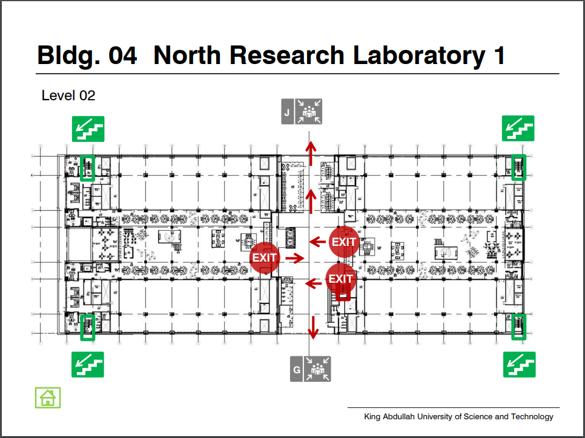

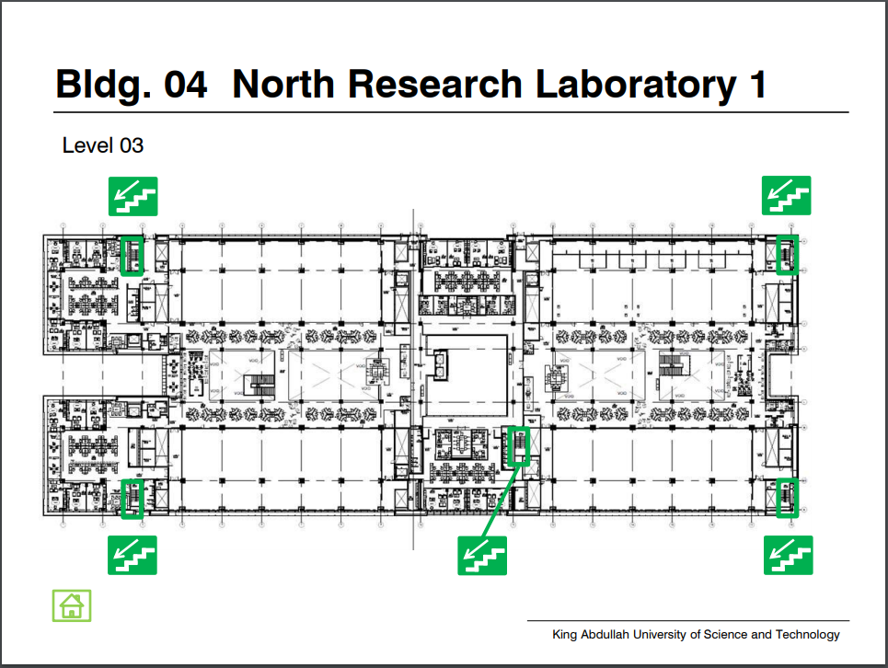

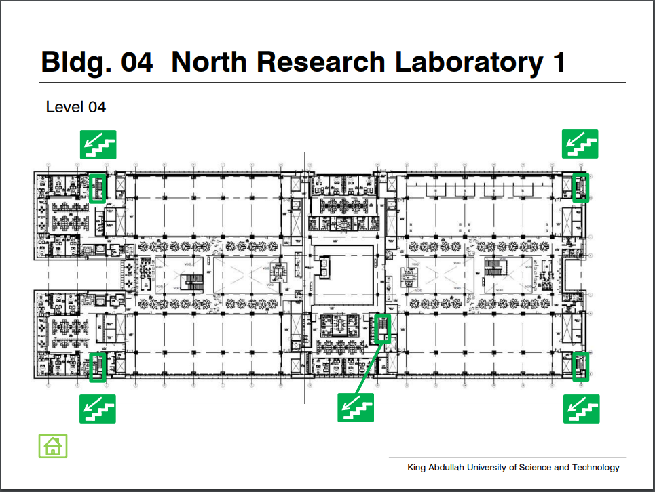

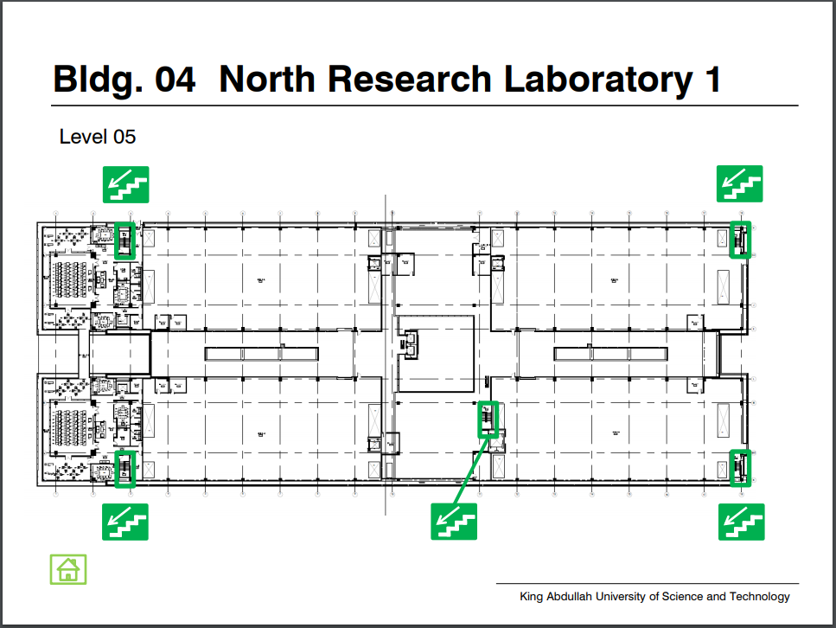

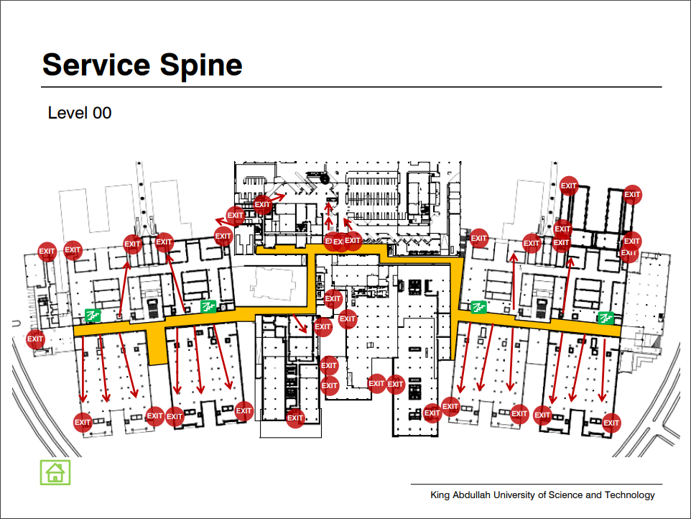

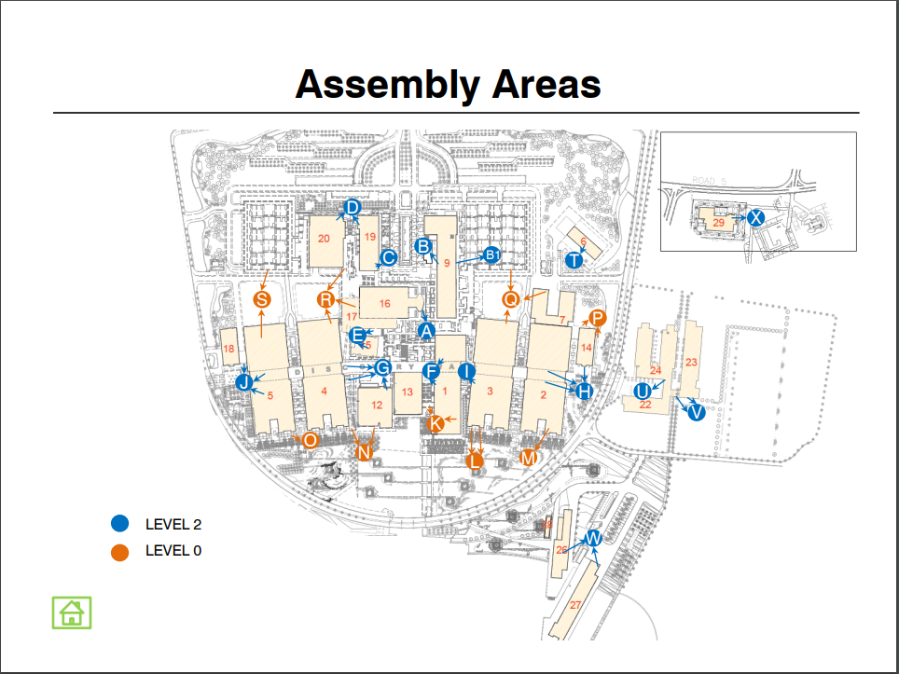

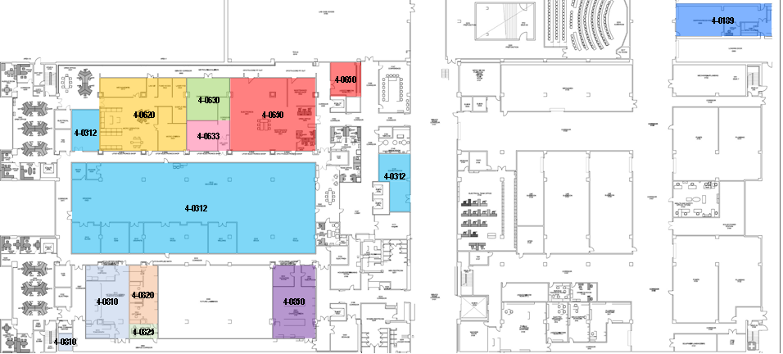

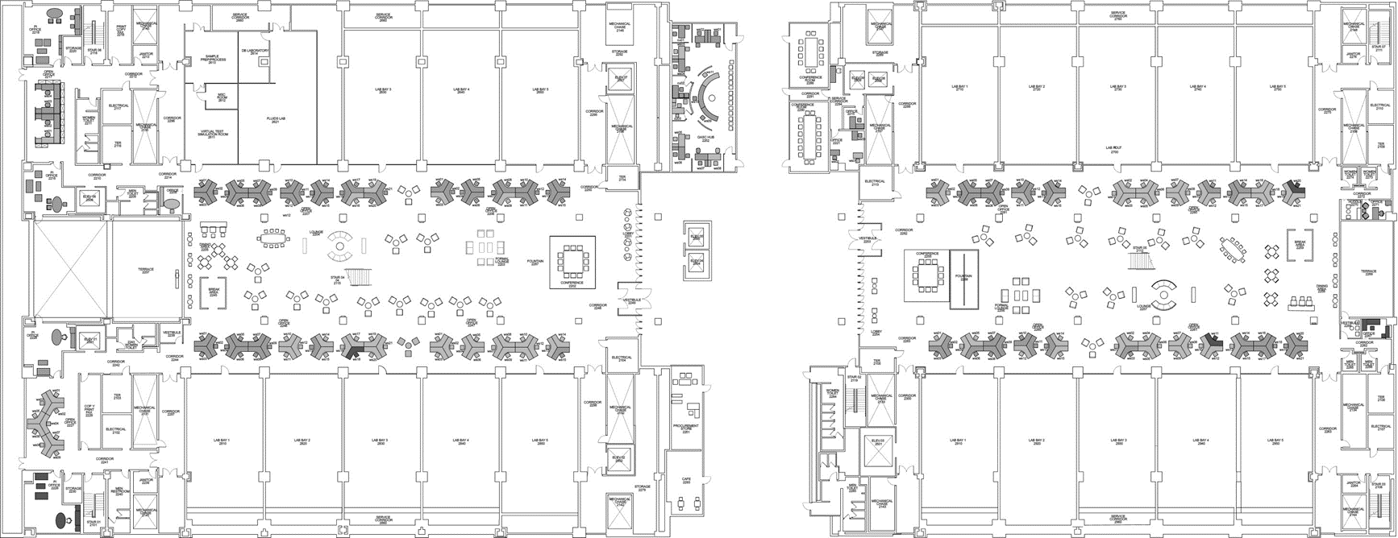

**Assessment Space Lab Name PI LSR Alternate LSR Comments**

|  |  |  |  |  |
| --- | --- | --- | --- | --- |
| 4-2610 | Composite and Heterogeneous Material Analysis and Simulation (COHMAS) Lab  Area 1 | Gilles Lubineau | Muhammad Seraj | Caroline Luciani |
| 4-2620 | High-Speed Fluids Imaging Laboratory Area 1 | Sigurdur Thoroddsen | Krishna Raja | Abdullah Alhareth |

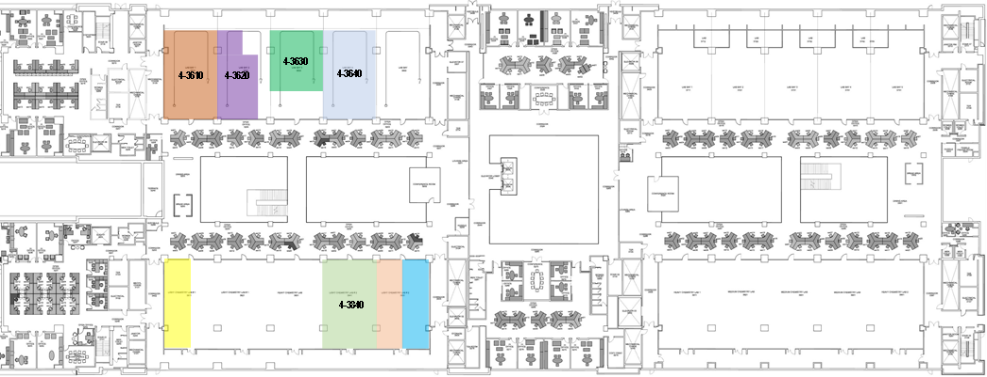

Assessment Space Lab Name PI LSR Alternate LSR Comments

**4-3810A**

**4-3850A**

**4-3850B**

|  |  |  |  |  |
| --- | --- | --- | --- | --- |
| 4-3610 | Human Genetics & Therapeutics | Bruno Reversade | Jezabel Garcia Parra | Emmanuelle Szenker Ravi |
| 4-3620 | Subcellular Metabolism Lab | Nouf Laqtom | Nouf Laqtom |  |
| 4-3630 | Laboratory for Applied Virology and Precision Medicine | Fabian Schmidt | Cecilia Lozano Sandoval | Alexander Salibi |
| 4-3640 | Integrative RNA Biology in Health and Disease (IRBHD) | Imed Gallouzi | Shahryar Khattak | Nadia Steiner |
| 4-3810A | Viral Vector Lab | Leena Ibrahim | Qing Xu |  |
| 4-3840 | Alsulaiman Lab | Dana Alsulaiman | Muhsin Ali | Erol Hasan/Fatima Samman |
| 4-3850A | Daniel Lab | Daniel Daniel | Marcus Lin |  |
| 4-3850B | SPLASH Lab | Tadd Truscott | Sandip Dighe |  |

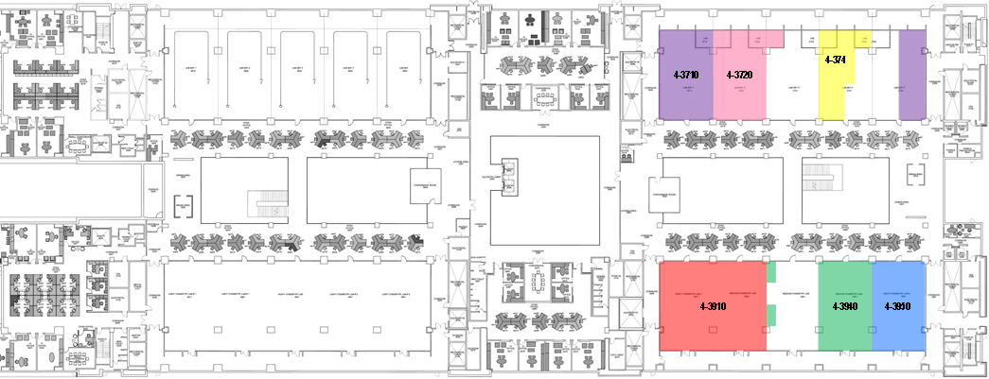

Assessment Space Lab Name PI LSR Alternate LSR Comments

|  |  |  |  |  |  |
| --- | --- | --- | --- | --- | --- |
| 4-3710 | Oxide and Organic Nanomaterials for the Environment (ONE) Laboratory | Cafer Yavuz | Si Thien Nguyen |  | Including 4-3750B |
| 4-3720 | Intensification of Materials and Processes (IMAT) | Carlos Grande | Rafael Luan Canevesi |  |  |
| 4-3740 | Maestre Lab | Fernando Maestre Gil | Pooja Thakur |  |  |
| 4-3910 | Smart Hybrid Materials Lab | Niveen Khashab | Basem Moosa |  | Including 4-3920 |
| 4-3940 | Szekely Lab | Gyorgy Szekely | Rifan Hardian |  |  |
| 4-3950 | Nanostructured Polymeric Membrane Laboratory | Suzana Nunes | Lakshmeesha Upadhyaya | Livia Loiola |  |

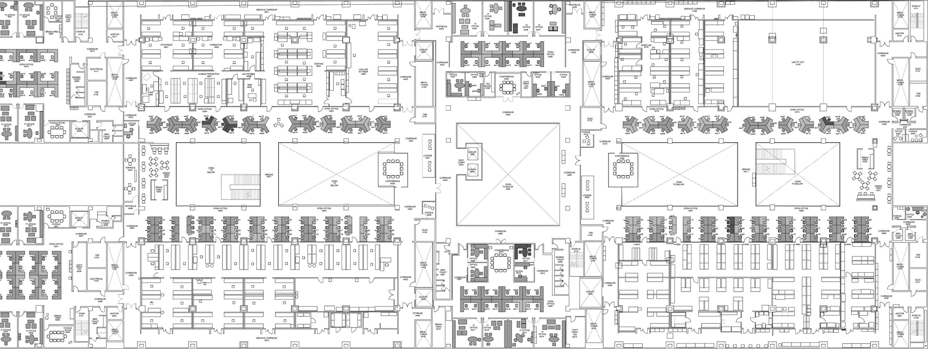

Assessment Space Lab Name PI LSR Alternate LSR Comments

|  |  |  |  |  |
| --- | --- | --- | --- | --- |
| 4-4610 | Ingo Synthesis Lab | Ingo Pinnau | Ali Alansari |  |
| 4-4620 | Membrane Formation Lab | Mohamed Eddaoudi | Ali Alansari |  |
| 4-4630 | Characterization Lab | Mohamed Eddaoudi | Ali Alansari |  |
| 4-4640 | Membrane Testing Lab | Mohamed Eddaoudi | Ali Alansari |  |
| 4-4650 | Hollow Fiber Lab | Mohamed Eddaoudi | Ali Alansari |  |
| 4-4710 | Nanostructured Functional Materials Lab | Zhiping Lai | Xiaowei Liu |  |
| 4-4720 | Inorganic Membranes Lab | Zhiping Lai | Xiaowei Liu | Including 4-4730 |

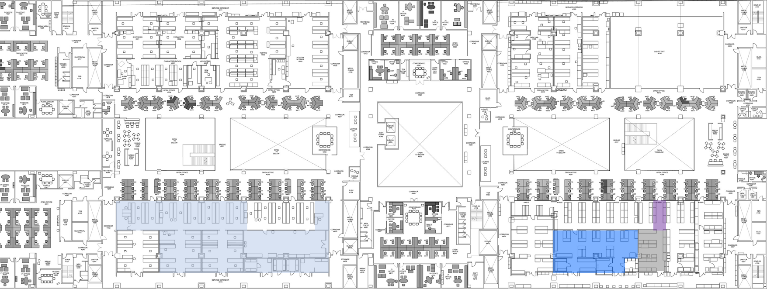

|  |  |  |  |  |  |
| --- | --- | --- | --- | --- | --- |
| **Assessment Space** | **Lab Name** | **PI** | **LSR** | **Alternate LSR** | **Comments** |
| 4-4810 | Saikaly Lab | Pascal Saikaly | Mohammed El Shaer | Imene El Tall |  |
| 4-4830 | WDRC Shared Area 4 | Johannes Vrouwenvelder | Mohammed El Shaer | Imene El Tall |  |
| 4-4910 | Johannes Lab | Johannes Vrouwenvelder | Mohammed El Shaer | Imene El Tall |  |
| 4-4920 | Picioreanu Lab | Cristian Picioreanu | Mohammed El Shaer | Imene El Tall |  |
| 4-4922 | WDRC Shared Area 6 | Johannes Vrouwenvelder | Mohammed El Shaer | Imene El Tall |  |
| 4-4930 | Crystallization and Green Solvents Lab | Witkamp Geert-Jan | Mohammed El Shaer | Imene El Tall |  |
| 4-4940A | Ghaffour Lab | Noreddine Ghaffour | Mohammed El Shaer | Imene El Tall | Including 4-4830A |
| 4-4940C | Hong Lab | Peiying Hong | Mohammed El Shaer | Imene El Tall | Including 4-4933 and 4-4943 |
| 4-4950 | Interfacial Lab | Himanshu Mishra | Mohammed El Shaer | Imene El Tall | Including 4-4940B |

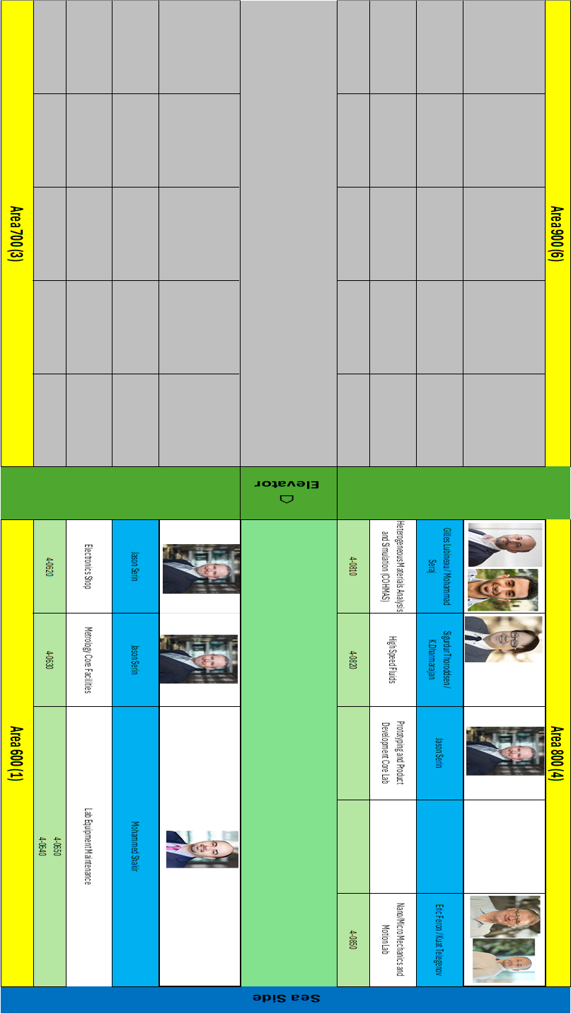

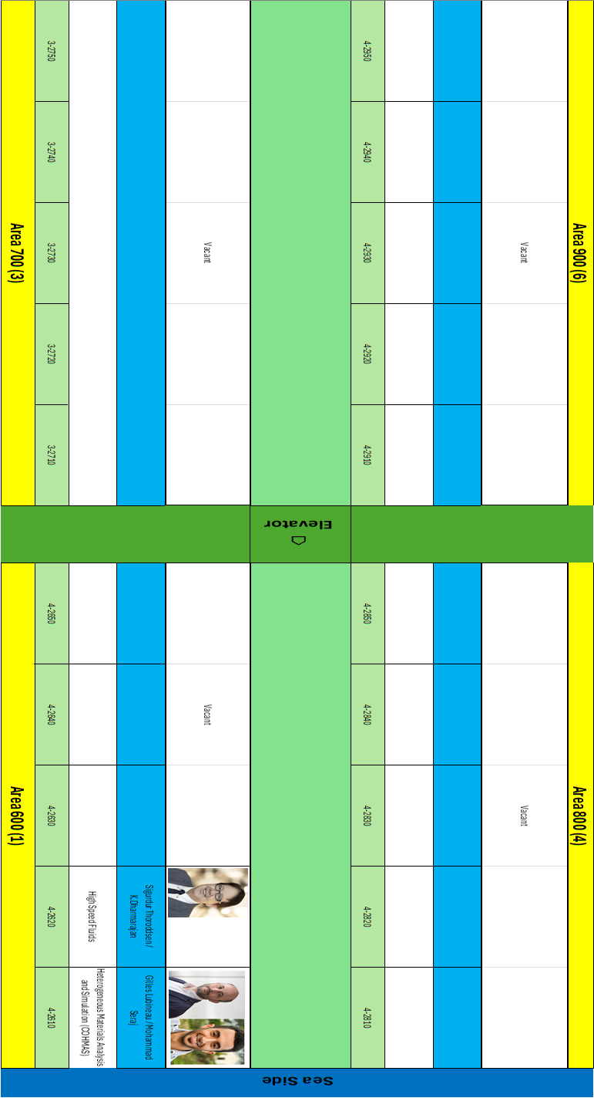

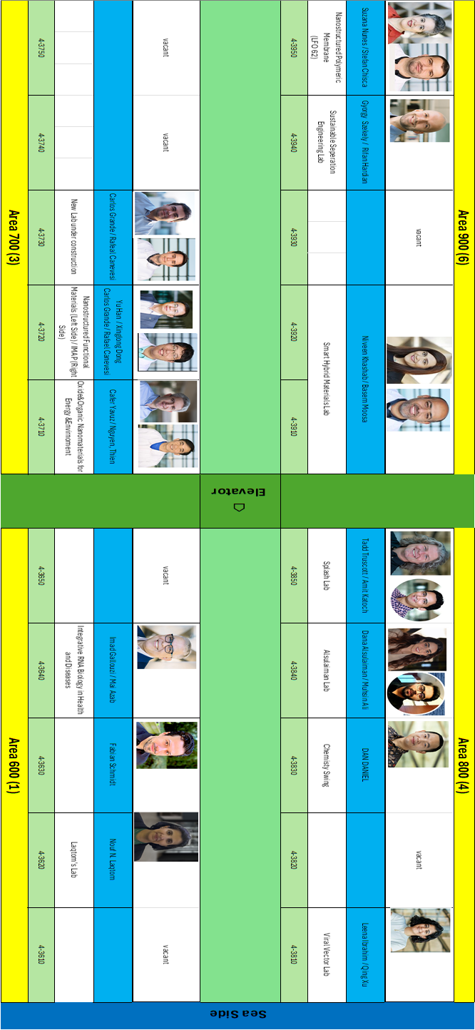

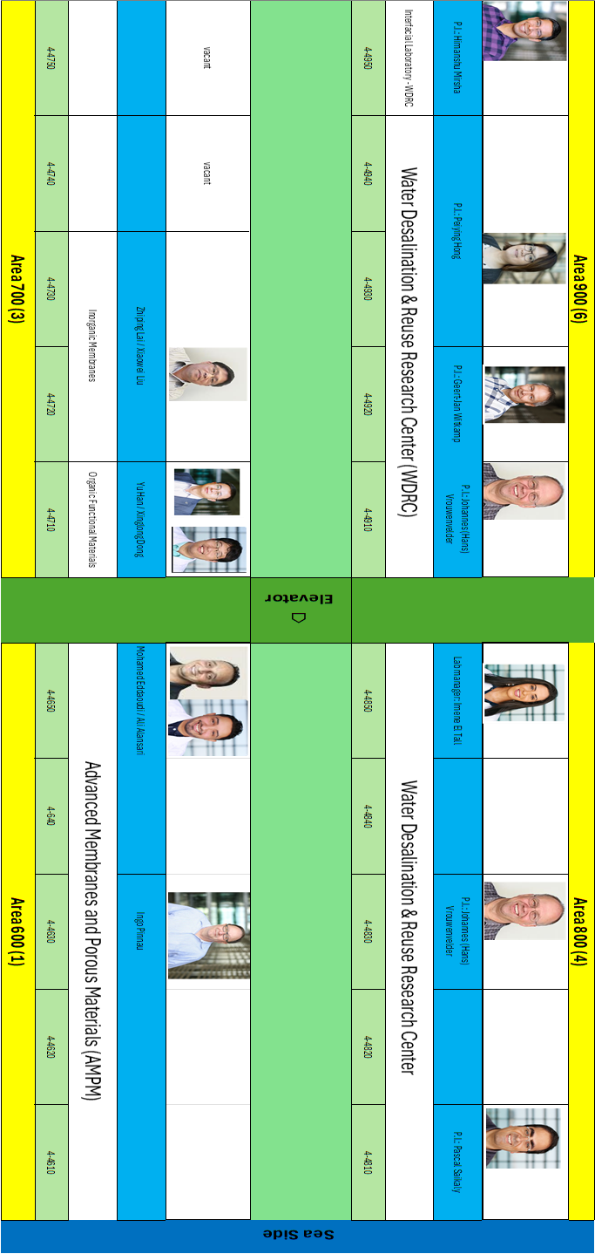

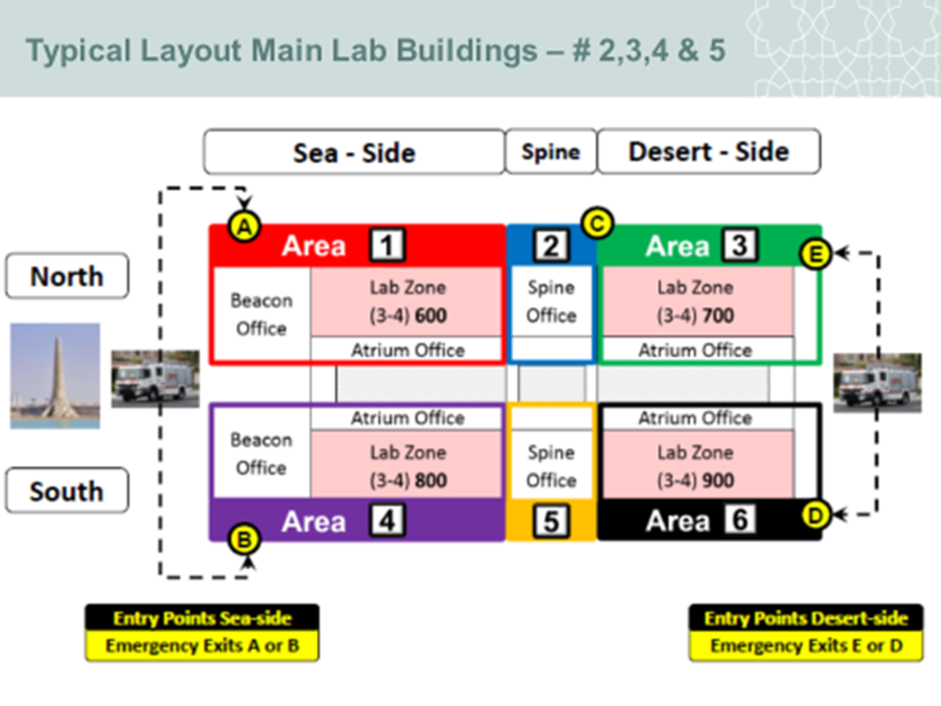

|  |  |  |  |  |  |  |
| --- | --- | --- | --- | --- | --- | --- |
| ***LEVEL / AREA*** | ***A1*** | ***A2*** | ***A3*** | ***A4*** | ***A5*** | ***A6*** |
| ***L1*** |  |  |  |  |  |  |
| ***L2*** |  |  |  |  |  |  |
| ***L3*** |  |  |  |  |  |  |
| ***L4*** |  |  |  |  |  |  |
| ***L5*** |  |  |  |  |  |  |

**BUILDING EVACUATION ROLL CALL SHEET**