Guidelines for Working with Nanomaterials

**Executive Summary**

The purposeful creation of engineered nanomaterials is a relatively recent discovered technology. The ability to create very small scaled structures (<100 nanometers) has brought forward the increased ability to perform tasks much more efficiently due to nanomaterials increased surface area compared to the same bulk material. Some of the physical and chemical properties that may be effected by this change include;

* Color
* Melting point
* Crystal structure
* Reactivity
* Electrical conductivity
* Magnetic properties
* Mechanical strength

Obviously if the above stated properties of a material can be transformed, so too can its hazard profile! This new technology and altered properties can also bring with it other less desirable biological interactions as well. Some of these hazards are still unknown and are currently being investigated. Therefore extreme care should be afforded while dealing with nanomaterials until their hazard profile is fully understood.

Use the flow chart below to determine if your material is a nanomaterial.



**Key take away points for working with nanomaterials**

* Know what PPE will protect you – your life may very well depend on it!
* Work with nanomaterials as much as possible in a glove box, chemical fume hood, biosafety cabinet or ventilated enclosure. *Glove boxes and chemical fume hoods are preferred!*
* Use HEPA (High Efficiency Particulate Air) filters for any equipment used for work with nanomaterials e.g. Biosafety cabinets, respiratory cartridges, vacuum cleaners, etc.
* Keep agitation and/or movement of nanomaterials to a minimum to prevent the creation of airborne particles. Some nanomaterials can stay suspended in the air for days!
* Always thoroughly clean up equipment and work area when finished working with nanomaterials to prevent chemical exposures from accidental contact.
* Know how to clean up a nanomaterial spill before working with it.

**Note:** Due to the hazards associated with nanomaterials, consider using less hazardous forms when possible rather than dry solids which have a higher risk for exposure. Examples:

* + Nanomaterials suspended in a gel.
  + Nanomaterials bound or fixed to a solid substrate.
  + Nanomaterials suspended in a colloidal solution.
  + Nanomaterials wetted in a slurry.

**Important considerations and issues**

* Do these procedures require prior approval (i.e. PI approval) before work begins?
* Do these guidelines apply to all of the PI’s laboratories or specific ones?
* Is this document guideline alone sufficient or are other reference materials required? e.g. equipment manuals, reading background information, etc.
* Is there any prerequisite training before work is to begin with this type of material? e.g. basic compressed gas work, operating equipment or instruments, etc.
* Have you done a thorough risk assessment before working with this type of material?
* Any special First Aid issues while working with these types of materials?
* Any special tips, tricks, advice or comments to add? If so, then edit this document and add it.

**Overview of Hazards (Hazard Awareness)**

According to the Occupational Safety and Health Administration (OSHA) nanomaterials are: “Engineered nanoscale materials or nanomaterials are materials that have been purposefully manufactured, synthesized, or manipulated to have a size with at least one dimension in the range of approximately 1 to 100 nanometers and that exhibit unique properties determined by their size.” Nanomaterials with all three dimensions under 100 nm are referred to as nanoparticles. Even though DNA and RNA can fulfill the definition of nanomaterial they are generally not considered nanomaterials.

|  |  |  |  |  |
| --- | --- | --- | --- | --- |
| **Carbon Based** | | **Metal Based** | | |
| **Graphenes** | **Polymeric (Hydrocarbon Polymers)** | **Metals** | **Ceramics (Metal Oxides)** | **Semiconductors (Quantum Dots)** |
| Carbon Nanotubes (single walled) | Polymersomes | Iron – nano scale | Aluminum Oxide (Al2O3) | Aluminum Gallium Arsenide (AlGaAs) |
| Carbon Nanotubes (Double walled) | Nanogels | Copper – nano scale | Cerium Oxide (CeO2) | Cadmium Selenide (CdSe) |
| Carbon Nanotubes (Multi-walled) | Organic nanoparticles | Gold – nano scale | Iron Oxide (Fe3O4 and Fe2O3) | Cadmium Sulfide (CdS) |
| Dendrimers | Lipid-polymer nanomaterials | Silver – nano scale | Titanium Dioxide (TiO2) | Cadmium Telluride (CdTe) |
| Fullerenes (Buckeyballs) | Core-shell polymeric nanomaterilas |  | Zinc Oxide (ZnO) | Gallium Arsenide (GaAs) |
| Nano wires |  |  |  | Indium Phosphide (InP) |
| Nanocones |  |  |  | Lead Selenide (PbSe) |
|  |  |  |  | Lead Sulfide (PbS) |
|  |  |  |  | Zinc Selenide (ZnSe) |
|  |  |  |  | Zinc Sulfide (ZnS) |
|  |  |  |  | Zinc Telluride (ZnTe) |

Researchers utilizing nanomaterials **must** read and understand manufacturer’s Safety Data Sheet (SDS) prior to commencing work with such materials. If the material is an engineered or synthesized material with its hazards being unknown, then it must be handled as if it was a highly toxic material. Purchased Nanomaterials may have the below GHS (Globally Harmonized System) pictograms identified on their containers. Nanomaterials created in the laboratory should be clearly labelled “**Nanomaterials**” along with any other relevant information such as “**Cadmium sulfide (CdS) Quantum Dots**”.

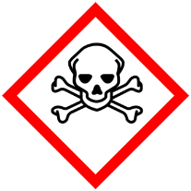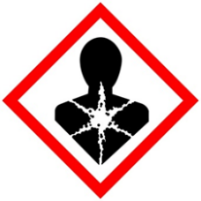

**Warning:** Additionally, due to the increased surface area that nanomaterials have, dust formations of nanomaterials may be much more flammable than their equivalent bulk material.

Due to the rapid development in the field of nanomaterials and the unknown hazardous nature of some nanomaterials, it is advised to see the websites below for recent discoveries concerning nanomaterials. This should be done during the lab’s annual Lab Safety Plan (LSP) review and when updating any laboratory specific SOPs.

Handling Nanomaterials:

[*Protecting Workers during the Handling of Nanomaterials*](https://www.cdc.gov/niosh/docs/2018-121/)

Nanomaterial Reactor Operations:

[*Protecting Workers during Nanomaterial Reactor Operations*](https://www.cdc.gov/niosh/docs/2018-120/)

Production and Down Stream Processing:

[*Protecting Workers during Intermediate and Downstream Processing of Nanomaterials*](https://www.cdc.gov/niosh/docs/2018-122/)

Nano toolkit from California Nanosafety Consortium of Higher Education

[Nanotool Kit](https://ehs.ucr.edu/laboratory/nanomaterials/nano%20toolkit%202012%200419%20updated.pdf)

Posters of Nanomaterial Guidelines:

[*Controlling Health Hazards When Working with Nanomaterials*](https://www.cdc.gov/niosh/docs/2018-103/)

Website for latest information on Nanomaterials:

[www.nano.gov](http://www.nano.gov)

OSHA standards on Nanomaterials:

[www.osha.gov/dsg/nanotechnology/nanotech_standards.html](http://www.osha.gov/dsg/nanotechnology/nanotech_standards.html)

OSHA’s webpage for additional resources:

[www.osha.gov/dsg/nanotechnology/nanotech_addinfo.html](http://www.osha.gov/dsg/nanotechnology/nanotech_addinfo.html)

**Examples of Nanomaterials used in** *Insert PI’s Name Here* **group lab.**

*PIs and Lab managers: enter nanomaterials used in your lab in this section.*

|  |  |  |
| --- | --- | --- |
| **Nanomaterial Name & Formula** | **CAS #** | **Location** |
|  |  |  |
|  |  |  |
|  |  |  |

**Engineering Controls and Safe Work Practices**

* All work utilizing nanomaterials must be done in a properly operating chemical fume hood, glove box, biosafety cabinet or appropriate engineering control with emergency spill kits accessible and nearby. *Glove boxes and chemical fume hoods are preferred.*
* Be sure all equipment being utilized is compatible with the nanomaterials being used.
* Use HEPA (High Efficiency Particulate Air) filters for any equipment used for work with nanomaterials e.g. Biosafety cabinets, respiratory cartridges, vacuum cleaners, etc.
* De-clutter and remove from work area any incompatible material that is not necessary.
* Inexperienced users of nanomaterials must be supervised while performing experiment.
* Utilize appropriate volume (not to exceed maximum volume) containers for most transfers of nanomaterials. Ideally only utilize 50% of a containers capacity.
* Always thoroughly cleanup equipment and work area when finished to prevent chemical exposures from accidental contact with nanomaterials. Use wet cleanup methods and not dry sweeping.
* Always perform manipulations of nanomaterials in an environment with little or no air currents. These air currents can make the handling of these materials difficult and dangerous to your health by creating airborne particles.
* When handling nanomaterials try to keep unnecessary agitation to a minimum. Even the agitation of solutions (stirring, sonicating, etc) has been reported to create airborne particles.
* Transfer nanomaterial samples between workstations (i.e. from glove box to fume hood, from furnace to glove box, etc) in sealed, unbreakable, and labelled containers.
* Utilize anti-static ionizers, instruments, and/or electrostatic shields to reduce electrostatic “cling” during dry transfers.

**Zerostat Anti-Static Instrument from Sigma-Aldrich**

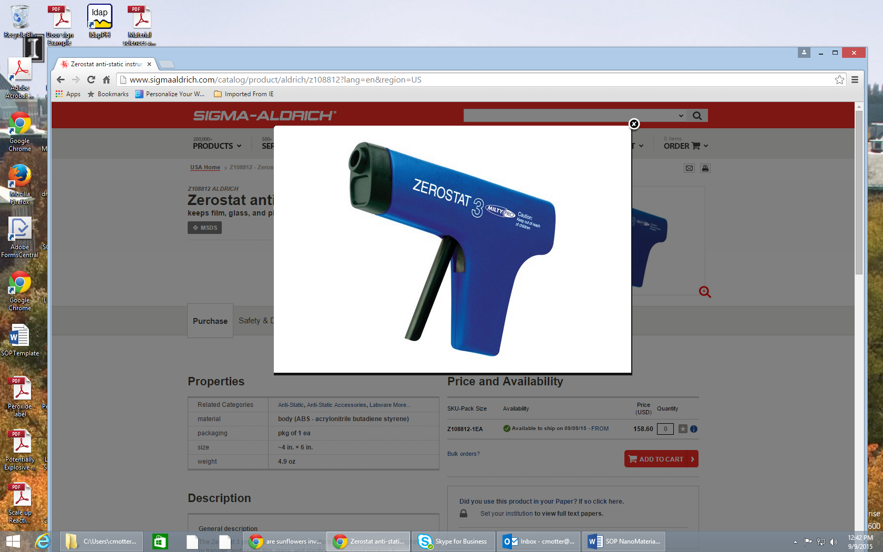

**Anti-static devices available from Sigma-Aldrich (Anti-static ionizer) and VWR (METTLER-TOLEDO Ionizer Antistatic Systems) respectively.**

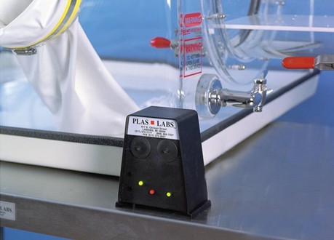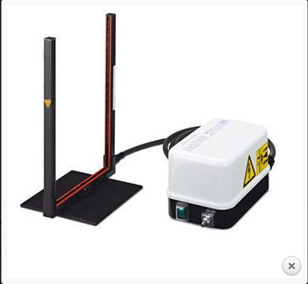



* Whenever possible utilize simple and disposable equipment to reduce airborne dispersions of nanomaterials such as tacky-mats and antistatic paper. Also try using nanomaterials in different forms such as bound in a polymer or dispersed in a liquid suspension. These methods help to reduce airborne dispersions of nanomaterials.

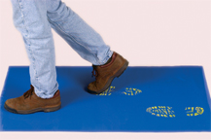

* In laboratory’s that work with nanomaterials it is a good practice to post signs, “nanomaterials present-use special precautions”.

**Examples of septa that maybe required for working with nanomaterials. Septa help with maintaining a sealed enclosure but still allow for the addition and withdrawal of material via needle-syringe.**

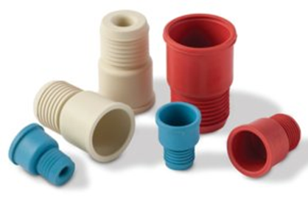 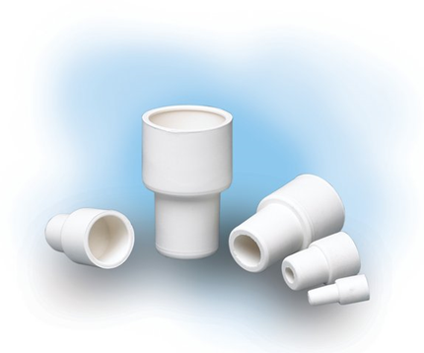

**Safe Work Practices for Solid Nanomaterials – Closed Container**

**Note:** *Method should be performed in a glove box or ventilated enclosure.*

1. Place the vessel (with lid) you intend to place the nanomaterial into on a stable surface.
2. Open the vessel and slowly and carefully insert a spatula of material into the vessel. Immediately close the vessel. **Be sure to also treat the original container gingerly to keep from forming airborne particles.**
3. Material is now ready for use.
4. Be sure to properly close the original container of material. Properly seal the lid if necessary. Return it to storage.



**Safe Work Practices for Solid Nanomaterials – Slurry/Solution Technique**

**Note:** *Method should be performed in a glove box or ventilated enclosure.*

1. Place the vessel you intend to place nanomaterial into on a stable surface (magnetic stir bar is optional).



1. Open the vessel and slowly and carefully insert a spatula of material into the vessel. Immediately close the vessel. **Be sure to also treat the original container gingerly to keep from forming airborne particles.**
2. Be sure to properly close the original container of material. Properly seal the lid if necessary. Return it to storage.
3. With a septa used to close the container, insert needle through septa and inject solvent that will solubilize or form a slurry with the nanomaterial you are working with.
4. Make sure it is well mixed.
5. While mixture is well agitated, withdraw desired amount out via syringe or by pouring into another desired vessel via funnel. **Note:** be careful when pouring as droplets splattering on surfaces can still form airborne particles. Pipette withdrawal is another option dependent upon slurry/solution thickness.
6. At this point the withdrawn amount can be further diluted (e.g. volumetric flask) or dried down into another desired vessel. This technique simply helps to prevent the formation of dusts/airborne particles during transfers.



**Safe Work Practices for Solid Nanomaterials – Glove Box Technique**

1. Place the vessel and lid you intend to place your nanomaterial into in the ante-chamber of a dry glove box along with all the reagents and utensils you intend to use.
2. Close the ante-chamber door and evacuate the ante-chamber of atmospheric air as the manufacturer recommends. Be certain the main chamber is already under an inert atmosphere.
3. Once complete, insert hands/arms into the glove port/sleeve assembly and open the interior ante-chamber door to the ante-chamber. Retrieve the vessel, reagents and utensils you intend to use and place them in the main chamber.
4. Now close and seal the interior ante-chamber door and start manipulating the material as if it were a regular solid chemical but only in a more slow and deliberate fashion in order to keep the formation of airborne particles to a minimum.
5. Once finished, be certain the vessel containing the nanomaterial is in is closed and sealed. Clean up main chamber accordingly.
6. Once you have confirmed the ante-chamber exterior door is still closed, open the interior ante-chamber door and place the vessel, reagents and utensils in the ante-chamber.
7. Close the interior ante-chamber door and seal it.
8. Open exterior ante-chamber door to retrieve your vessel of nanomaterial and other materials.
9. Vessel containing the nanomaterial is now ready for use.



**Personal Protective Equipment (PPE)**

In addition to the minimum PPE set forth in [PPE Standard for KAUST Laboratories](https://oldhse.kaust.edu.sa/Services/PublishingImages/Pages/LabSafety/PPE_Standard_For_KAUST_Laboratories.pdf), researchers need to select any additional PPE that should be utilized. See SDS section 8 (Exposure Controls/Personal Protection) or [KAUST laboratory Safety Manual](https://oldhse.kaust.edu.sa/Services/Pages/LabSafetyManual/Introduction.aspx) for more information.

Gloves: disposable  double gloving chemically resistant insulated

Eye wear: goggles safety glasses face shield

Lab coat: cotton flame resistant  apron

Respirator: Filter cartridge type:________________________

*Respirator usage requires enrolling in the [Respiratory Protection Program](https://oldhse.kaust.edu.sa/Services/Pages/respiratoryprotectiontraining.aspx)

other____________________________

**Respirator usage is optional! –** Engineering controls should be used as much as possible when working with nanomaterials. If you believe your current engineering controls are not sufficient and a respirator is needed, see [Respiratory Protection Program](https://oldhse.kaust.edu.sa/Services/Pages/respiratoryprotectiontraining.aspx) for further information regarding possible respirator usage.Further, due to the unknown hazardous nature that many nanomaterials may pose it may be prudent or necessary to utilize special respiratory equipment (e.g. filters) designed for the use of nanomaterials.

**Storage**

Nanomaterials must be stored:

* According to manufacturers’ SDS.
* With quantities kept to a minimum.
* In a compatible manner with other reagents.
* With the appropriate chemical nomenclature along with the word “**Nanomaterial**” clearly and legibly written on the container. This is to communicate its special properties as a nanomaterial.

**Note:** Nanomaterial waste too needs to be labelled as “**Nanomaterial**”.

**Emergency Procedures**

**Spill kit for nanomaterials**

An ideal spill kit for nanomaterials should be composed of the following;

* Chemically resistant gloves
* Absorbent pads (10-15)
* Sealable plastic bags (ziplocs)
* Liquid spray bottle with fine misting ability
* 5 gallon plastic pail with lid

**Note:** Due to the need to reduce airborne particles, a dust pan and whisk broom are not recommended for the cleanup of nanomaterials.

Place all listed materials in the 5 gallon pail and label the pail “Spill Kit”. Place spill kit in an easily accessible location where all lab personnel are aware of. All lab personnel should be [trained](https://oldhse.kaust.edu.sa/AwarnessEngagementAndTraining/Pages/Research-Classroom-Training.aspx) to handle spills of the materials they are working with before they begin lab work.

**Incidental Spills**

To use spill kit, first don personal protective equipment (PPE) of chemically resistant gloves, lab coat, and safety glasses. If necessary (and if available) use a respirator as well. If nanomaterial is a:

* **Solid –** wet absorbent pad with a non-volatile solvent that is chemically compatible with the pad to be used and the nanomaterial that is to be cleaned up (water is usually best). Begin wetting nanomaterial by spray misting (using fine misting spray bottle) contaminated area with liquid. Wetting nanomaterial first helps to reduce nanomaterials from becoming airborne particles. Then begin to wipe material up occasionally using fine misting spray bottle to keep nanomaterial wet. Then place material in sealable plastic bags or pail. Do not subject contaminated pads to excessive movement i.e. dropping them, wringing liquid from them, etc.
* **Liquid** – carefully place absorbent pads on liquid spill. Let stand for a few minutes to absorb liquid. Carefully place soiled pads in sealable plastic bags or pail. Seal the waste bags or pail and store in chemical fume hood until submitted for waste disposal. Carefully and thoroughly wash spill area with soap and water. Dispose of all soiled spill material through the KAUST hazardous waste management program (see **Disposal** section).

**Major Spills**

If an unmanageable spill of nanomaterial happens inside the fume hood, close the sashes of the chemical fume hood. Immediately evacuate the laboratory and call 911 (landline) (012-808-0911 from cell phone) to alert emergency responders.

If an unmanageable spill of nanomaterial happens outside the fume hood, immediately evacuate the laboratory and call 911 (landline) (012-808-0911 from cell phone) to alert emergency responders. Place signage on door alerting others not to enter laboratory.

**First Aid**

Rinse off exposed areas with large quantity of water for 15 minutes. If it is during regular work hours, inform the PI or supervisor, and seek medical assistance. Call 911 (landline) (012-808-0911 from cell phone) for life threatening exposure.

**Waste Disposal**

Upon completion of working with nanomaterials, dispose of material;

* In an appropriate constructed container and clearly labelled as to the contents and its hazards.
* Submit for disposal utilizing the established proper channels and methods outlined in the KAUST [Hazardous Waste Manual](https://oldhse.kaust.edu.sa/Services/Documents/Hazardous%20Waste%20Manual.pdf).
* Notify campus Hazardous Waste ([environmentmatters@kaust.edu.sa](mailto:environmentmatters@kaust.edu.sa)) if you have further questions.
* HEPA (High Efficiency Particulate Air) filters used for work with nanomaterials e.g. Biosafety cabinets, respiratory cartridges, vacuum cleaners, etc should also be disposed as hazardous waste as well.

**Training and Documentation**

Training conducted by (print name):____________________________________________

Trainers signature and date:__________________________________________________

Training venue and method. Check all that apply: Classroom/lab lecture

One-on-one Demonstration Hands on Experience SOP review

|  |  |  |
| --- | --- | --- |
| **Date** | **Name** | **Signature** |
|  |  |  |
|  |  |  |
|  |  |  |
|  |  |  |
|  |  |  |
|  |  |  |
|  |  |  |
|  |  |  |
|  |  |  |
|  |  |  |